



Autonomous exploration robot “Pathfinder” with Open-Source Software and LiDAR technology

AY 21/22 – CIS017-3: Undergraduate Thesis Report

BSc (Hons) Department of Computer Science and Technology The UNIVERSITY OF BEDFORDSHIRE

**Author** **Supervisor**

Raimonds Buls, ID 1912944 Dr Renxi Qiu raimonds.buls@study.beds.ac.uk renxi.qiu@beds.ac.uk

**Abstract**

Intelligent autonomous robots are needed in various applications, such as space, transportation, industry, and defense. Additionally, mobile robots can perform several tasks like material handling, disaster relief, patrolling, and rescue operations. Thus, it is necessary to have an autonomous robot that can travel freely within a static or dynamic environment. Navigation of mobile robots through cluttered environments is focused on achieving smooth and safe path-following and producing optimal path length from start to an end position. Researchers have explored several techniques for planning robot navigation paths related to this issue. The core problem – there is no ideal solution, yet.

The main focus of this research topic is on the navigation and path planning for autonomous robotics to successfully perform exploration task in an unknown environment. Besides making huge progress in autonomous robotics in past decades, there are still significant issues in path planning and navigation segments, which are fundamental parts of the development of autonomous robots. The research discussed relevant issues with navigation and path planning in mobile robots, available open-source SLAM packages, and algorithms they use, such as Gmapping, Explore_Lite, and RRT. With the development of open-source software ROS and Gazebo, and hardware for Turtlebot3 model Waffle PI. The results of testing proved, that project achieved the stated objectives and aims of the development of an autonomous exploration robot.

Key words: Robot Operating System (ROS) / Simultaneous localization and mapping (SLAM) / Gazebo / Gmapping / Turtlebot3 / Odometry / Explore_Lite / RRT

Dedicated to the loving mother Valentine Bule, who always supported me and was example of human being – “I am grateful and proud for each moment of my life being your son.”

**Acknowledgements**

I'd want to express my gratitude to my family for their unwavering support during this research endeavor and for allowing me to focus entirely on it for my academic career.

Thank you, Mitul Shukla, for providing incredible guidance within project management skills and other valuable skills within teaching program and beyond.

Thank you to Dayou Li for valuable guidance at the proposal stage of the project and in advanced robotics unit. That knowledge allowed to push software development skills with ROS and other tools.

I would like specially thank my project supervisor Renxi Qiu for helping through this project all stages. I would not have been able to complete this project to the appropriate standard without your direction and experience.

**Contents**

**Introduction** 6

**1.1** **Background** 6

**1.2** **Aims & Objectives** 7

**1.2.1** **Aim** 7

**1.2.2**  **Objectives** 7

**1.3**  **Research Methods** 7

**1.4**  **Scope & Limitations** 8

**1.4.1**  **Scope** 8

**1.4.2**  **Limitations** 8

**1.5 Gantt chart & Time Management** 10

**Literature review** 12

**2.1** **Related Work** 12

**2.2**  **Robot navigation techniques** 12

**2.2.1** **Global navigation method** 15

**2.2.2 Local navigation method** 16

**2.3** **SLAM** 17

**2.4**  **Robot Operating System (ROS)** 20

**2.5**  **GMAPPING** 23

**2.6**  **EXPLORE_LITE** 26

**2.7**  **RRT** 30

**Artefact design** 34

**3.1 SLAM, Path Planning and Navigation** 35

**3.2 Agile testing methodology** 36

**Artefact development** 37

**4.1 Gazebo – simulation** 37

**4.1.1 Ubuntu and Virtual Machine workstation** 37

**4.1.2 ROS** 39

**4.1.3 SLAM and autonomous navigation** 41

**4.2 Turtlebot3 – prototype** 43

**4.2.1 Hardware** 43

**4.2.2 Network configuration** 45

**4.2.3 Software wrap-up and Turtlebot3 launch** 47

**Testing, Results & Evaluation** 49

**5.1 Gazebo – simulation** 49

**5.1.1 Testing** 49

**5.1.2 Results** 51

**5.1.3 Evaluation** 53

**5.2 Turtlebot3 – factual environment** 53

**5.2.1 Testing** 53

**5.2.2 Results** 55

**5.2.3 Evaluation** 55

**Future Work & Conclusion** 56

**6.1 Future Work** 56

**6.2 Conclusion** 57

**List of references** 59

**Appendices** 62

**Appendix A – Turtlebot3 Hardware** 62

**Appendix B – Additional testing results** 63

**Appendix C – Technical documentation** 66

**C.1 – Introduction** 66

**C.2 – Setup** 66

**List of Figures** 69

**List of tables** 71

**Poster**…………………………………………………………………………….72

Chapter 1

# **Introduction**

## **Background**

Robots can be used in many applications, including exploring unknown areas. That can be extremely beneficial for human being, as certain areas are health hazardous and contain dangerous materials, as example reactor room in nuclear power plant or unexplored cave. Also, exploration can be used in civil engineering, where exploration of the building would allow to visualize design in software application for further needs. However, to successfully perform assigned tasks robot requires to sense the environment and identify objects, obstacles and free space around. Additionally, exploration can be considered as basis for other applications.

For exploration and perception of the surroundings, the robot uses a variety of sensors including a Camera, Radar, Sonar, or LiDAR. Each sensor type has its advantages and disadvantages for scanning the environment and providing crucial data. However, sensors should be considered as a tool to read the environment and while there are certain circumstances of their performance in different scenarios, the most important part takes place in algorithmic calculations for navigation and environment mapping.

Even with the development of hardware and software, there is still no ideal solution to solve navigation and path planning issues for autonomous mobile robots. Highly expensive and more accurate hardware and software allow to reduce the probability for error to occur, but that leads to additional costs, computation power required, and, most importantly for mobile robots, power consumption.

## **Aims & Objectives**

### **Aim**

The main aim of this research is to provide insight into navigation and path planning for mobile robots with SLAM and problems of navigation and pathfinding. With readily available open-source software and hardware resources develop an autonomous exploration robot in an unknown environment with a comparison of multiple options used. Additionally this research emphasis to promote open-source development in autonomous robotics and research with on SLAM topic.

### **1.2.2 Objectives**

1. Develop a SLAM-based software solution for exploration task.
2. Develop prototype robot with available open-source TurtleBot3 hardware from Robotis with use of LiDAR technology and SLAM-based software.
3. Develop improvement for SLAM-based software to achieve fully autonomous and efficient exploration task performance.

## **1.3 Research Methods**

Providing sufficient research on related topics will be done by analyzing topics and case studies that have been developed by other researchers in navigation and path-finding for autonomous exploration robots. Furthermore, the research will use the developed prototype as a basis for controlled experiments.

## **1.4 Scope & Limitations**

### **1.4.1 Scope**

This report examines the research of navigation and path planning SLAM methods for autonomous exploration robots and the technology involved to complete the required task of exploring unknown area and creating a map of the surrounding area with minimum human input and high efficiency. Specifically, that can be used for exploring and visualizing potentially hazardous areas so that vital information can be provided to safeguard human lives or as an image-based model to be used for architectural design and planning.

### **1.4.2 Limitations**

* Due to variety of the sensors and their own specifications, research will involve only laser-based technology LiDAR.
* Due to specifications of available LiDAR LDS-01, research focus is limited to 2D.
* The literature review will discuss the available open-source hardware; however, the University of Bedfordshire owns the TurtleBot3 Waffle Pi model which has the best potential for open-source hardware. This means that the research will not include physical testing in some areas with other hardware that was potentially cheaper or more efficient.
* The literature review will prioritize open-source software as the main software component. There are alternatives, but in the majority of situations, they are custom created for specific robot models from manufacturers or contain a lack of documentation for integration.
* Due to variety of the navigation packages and time investment to implement them and performs dedicated tests, research done will be limited to Gmapping, Explore_Lite and RRT packages.
* In order to provide additional visibility and mobility aspects of the prototype exploration task, open-source software integration will include the TurtleBot3 Waffle Pi model as well as a laptop.

## **1.5 Gantt chart & Time Management**

Time management was regarded one of the most crucial aspects of the final year project. With that in mind, early project development borderlines were established. The main focus on the artefact was formed between the initial stage of the authorised proposal form and the dissertation writing stage. The ability to create a balance between resource allocation for a final year project was made possible by having a vision of the project structure and time required.

The whole project was split into two major parts, relative to one year. In the first part, the main focus was set up for research in the related segment – software and hardware required, and developing artifact in simulation. During the second part, software used in simulations would be integrated into the assembled robot. Further, Gantt chart was designed a Gantt to track project progress and each phase of artifact development (Figure 1).

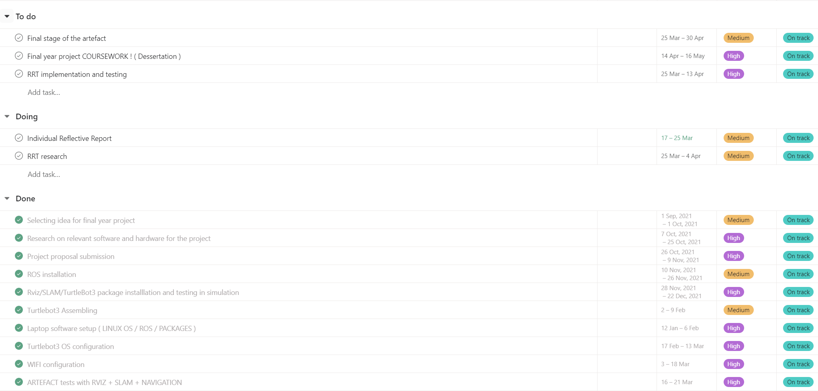

Figure 1: Revised Gantt Chart of the Final year project (From the reflective report).

On average for each stage of artifact development, it was allocated two weeks. To avoid further delays within the progress of the project, troubleshoot any issues encountered during the implementation of software and hardware, and conduct the necessary tests. I set up the goal to use time at the beginning of the week task was assigned, rather than leaving work for the end. Many unknown factors, especially those related to software installation and integration, were taken into account in moderation, which contributed in part to such a decision. A perfect example was encountered with WiFi issues. Although the problem was discovered at the start of the week, and it took three days for it to be fixed, the goal was achieved and the results were presented on Friday. Also, for project management, I used the Agile method. Using this method in previous units in the university, allowed me to work on multiple stages simultaneously and perform research and implementation at the same time rather than separating it.

Chapter 2

# **Literature review**

## **2.1 Related Work**

This project is definitely not new and there has been a wide variety of autonomous robots developed for the exploration and navigation. Examples can be seen by Boston Dynamics with their robot “Spot” (Bostondynamics.com, 2022) or “ANYMAL” developed by Anybotics (Anybotics.com, 2022). However, these examples are designed by manufacturers specifically to accomplish required task, including navigation and exploration. But accessibility to review methods and techniques they used is confidential and won’t be discussed. On the other hand, there is availability of open-source developed robots and software to perform research and benefit towards accessibility for the open robotics community. By far best potential for desired purpose matches with TurtleBot3 designed by Robotis (Robotis.com, 2022). To perform an extensive analysis of navigation aspects, it’s essential to provide insight of the problem and perform research of fundamentals related to open-source software developed.

## **2.2 Robot navigation techniques**

To assist in lowering the burden of labor on the human race, machines are performing physical tasks that were previously done by humans. However, there is a need for a special thing that machines not only perform physical tasks but also make decisions and think like human beings. Artificial intelligence knowledge plays a pivotal role in making things intelligent and achieving this target. Path planning has been considered the most common problem for robot navigation since robots have to move from the starting position to the target position by avoiding obstacles. Initially, researchers concentrated on two-dimensional path planning, such as Choset (Choset, 2005) who researched two-dimensional path planning, avoiding bio-inspired algorithms. In the future, many surveys regarding mobile robots in a 2D environment were conducted.

In the field of robotics, mobile robot navigation is an important issue. Such robots possess an element of intelligence. Additionally, they have a wide range of applications, from transportation to industry to rescue robots. One of the most prominent and essential components of autonomous mobile robot navigation is path planning. Researchers have developed several methods for solving path planning problems over the last two decades. Path planning's purpose is to find a collision-free path from one location to another while keeping the cost low. Path planning can be classified into *static* and *dynamic* environments depending on the type of environment. *Static path planning* is used when obstacles do not vary their position over time, while *dynamic path planning* is used when obstacles change their location and orientation over time. This information can be separated into *online* and *offline* algorithms. The information about the environment is collected through a separately attached local sensor mounted on the robot in online path planning, and the robot then develops the map of the environment from the information fed from the locally attached sensors. Without the use of sensors, the robot has complete information about the surrounding environment when designing offline paths. Several solutions have been proposed so far to ensure adequate navigation. (Gul, Rahiman & Alhady, 2019).

Muna et al. (Hassani, Maalej, & Rekik, 2018) solved a wheeled mobile robot's multi-objective path planning problem using the chaotic particle swarm optimization (PSO) and firefly algorithm.

To plan the course of a robot in a static and dynamic environment, Ibraheem et al. (Ibraheem & Ajeil, 2018) used Particle Swarm and Modified Bat algorithms. The suggested method achieves the multi-objective functions of shortest distance and path smoothness for robots. They employed the gap vector method to avoid obstacles.

In depth research for robot navigation techniques was performed by Gul et al. (Gul, Rahiman & Alhady, 2019), where authors provide more information about other techniques implemented for obstacle avoidance and path planning and navigation. Researchers state, that navigation can be divided into two types: Global and Local, what was confirmed before by Maram et al. (Maram Alajlan, Koub̂aa, Cĥaari, Hachemi Bennaceur, & Ammark, 2001).

Essential part, that prior knowledge of the environment is required for global navigation, which is also known as Off-line mode for path planning, such as the Dijkstra algorithm (Soltani, Tawfik, Goulermas, & Fernando, 2002). Local navigation, also known as On-line mode for path planning, is a mode in which the robot determines its position and orientation and can control its mobility using externally attached sensors such as an ultrasonic sensor, a vision camera, or laser. Additionally, with other techniques involved and developed software orientation of the robot can be autocorrected.

### **2.2.1** **Global navigation method**

Aside from the well-known Artificial Potential Field (APF) or A star (A*) global navigation systems, the Dijkstra method is the simplest. In their study, Alija et al. (Alija 2015; Cui & Shi, 2011) found that the Dijkstra graph searching method is a well-defined, effective, and efficient way for locating a nonobstructive path that takes less time and computational complexity. The robot's surroundings are created, and the path is connected by a line so that the robot can easily approach the objective. The process is repeated until the best and most optimal solution is found from one node to the next. The robot is free to go to the new place after it has reached the desired target.

The Dijkstra algorithm is a graph-searching method that finds the shortest path by solving the optimal path problem with non-negative edge path costs. It's used to calculate the cost of getting from one spot to another. This technique is critical in traffic information systems, where tracking the source and destination is possible.

It is used to find the shortest distance between the beginning node and other nodes in a graph with the lowest cost. The algorithm's main goal is to determine the shortest distance between a beginning point and an endpoint repeatedly while excluding long-distance paths.

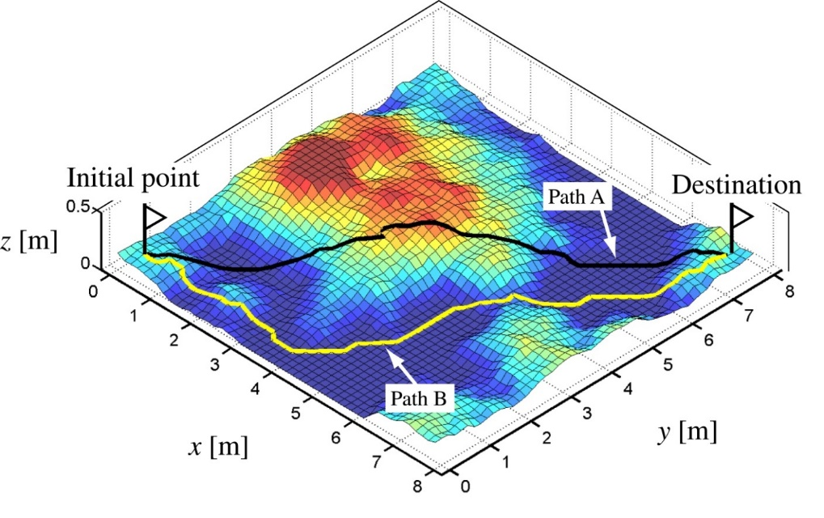

Figure 2: Graph-Based Path Planning: Dijkstra’s Algorithm (n.d) [Online]. Available <https://realitybytes.blog/> (Accessed 4 May 2022).

### **2.2.2 Local navigation method**

In local navigation techniques, sensors are usually employed to control the orientation and position of robot. For such use, LIDAR sensor is frequently used for automation purpose. LIDAR works independently as compared to GPS system; therefore, it has the capability of mapping the environment. LIDAR can be used independently but when coupled with other sensors like GPS, Inertial navigation system, and camera, it gives improved results (ROS, 2022).

For example, together with motor encoders it provides powerful positioning tool. This system can be employed for mapping the local environment to locate and identify the landmarks position, which in general is called as SLAM (Simultaneous Localization and Mapping). With the help of this technique, mobile robot automatically corrects its position and orientation remotely.

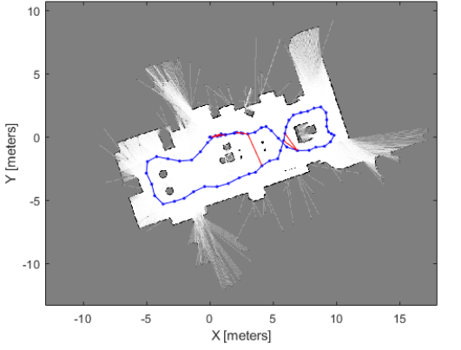

Figure 3: Occupancy Grid map built using Lidar SLAM (n.d) [Online]. Available at <https://www.mathworks.com/help/nav/ug/implement-simultaneous-localization-and-mapping-with-lidar-scans.html/> (Accessed 2 May 2022).

## **2.3 SLAM**

SLAM stands for Simultaneous Localization and Mapping and is a technique for creating a model of the surrounded environment and estimating a mobile robot position at the same time. In general, estimating a vehicle’s position on an already known map would not be a difficult task to accomplish. However, things are different, when a robot performs in an unknown environment or map is not pre-build. Many studies have been conducted on how to represent the environment as well as the robot's position, and the SLAM algorithm is one of the most commonly studied topics in robotics when it comes to mapping new environments and determining the robot's location.

System engineer and consultant B. Douglas (2020) properly address and explain this issue in his online autonomous navigation lecture with pose graph SLAM. In his example, a robot equipped with LiDAR is able to sense distances and angles of obstacles around. With the use of odometry from wheel encoders, it is also possible to track the robot’s relative position over time. In an ideal situation, with no errors from LiDAR or odometry measurements, a robot would be able to build the map and know its location at all times (Figure 4).

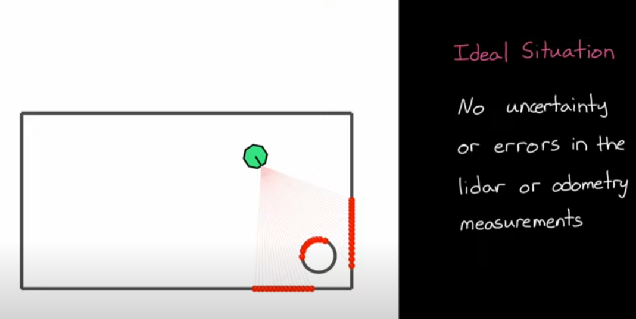

Figure 4: Imaginary Lidar scan of the robot towards obstacle

Realistically this will never take a place, as there is an error in wheel encoders and LiDAR. In his second example, with huge errors in odometry, real and estimated robot poses are different. That creates two different frames and produces an inaccurate map (Figure 5).

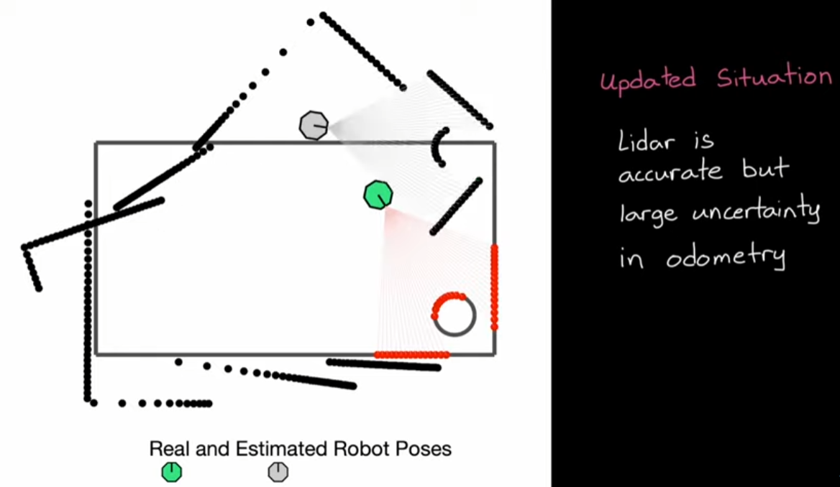

Figure 5: Map of obstacles wrongly resembling real environment

That’s one of the reasons why measurements results cannot be taken directly to produce a map. Using the close graph SLAM algorithm in his further example, allows to perform correction within frames. This is achievable by using loop closure of constraints between the relative distance of previous poses of the robot. Where information of relative distance used from counting wheel rotations. The principle underlying the near graph SLAM method, according to the author, is not limited to a certain collection of sensors. That means relative posture distances could originate from a different measurement source, such as the Inertial Measurement Unit (IMU), or GPS could offer external distance information. The key idea is that by estimating how far apart robot positions are and measuring how reliable the estimate is, it is possible to build the previously described limits and a loop between them (Figure 6).

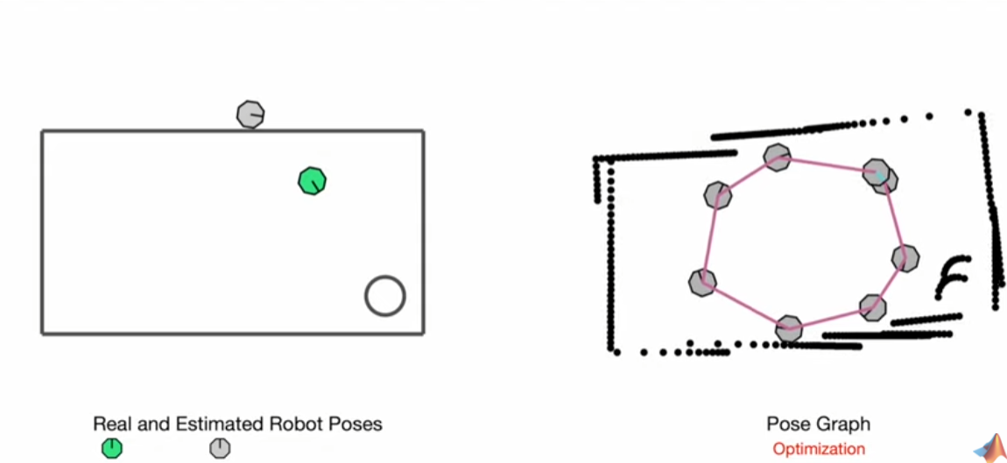

Figure 6: Pose Graph Optimization loop closure correction

While after one loop map would not be perfect and there would be errors in certain places between frames. Adding more loop closures would allow a continuous graph to improve its global model of the environment in past robot poses. But that would take a place as long as two connected poses are truly observing the same environment feature.

Finally, he emphasizes that it is preferable to miss a loop closure than to make an improper loop closure. That implies the robot can drive around more in the future and create accurate loop closures, but removing faulty ones is arduous because they continue to affect the Pose Graph Optimization process.

## **2.4 Robot Operating System (ROS)**

Prior to providing an in-depth analysis of the SLAM packages, it is essential to examine the software application where the SLAM packages are developed.

Although ROS stands to be an operating system, rather it should be considered as a meta-operating system, which contains a collection of software frameworks for robot development. Building a robot might be a complex task as there are many points to consider – motors, sensors, software, and batteries. All these things must work together seamlessly to accomplish the necessary task. ROS is one of the most popular, free, and open-source software that allows simplifying this process. It defines tools, components, and interfaces for building advanced robots. In general, the majority of robots are made up of actuators (things that move), sensors (things that read the world), and control systems (robot’s brain). With the ROS tools topics and messages, developers can build these components faster and easily connect them. These messages can be sent to different kinds of visualization and teleoperation tolls. That allows working with simulated robots, making the testing and training part more effective.

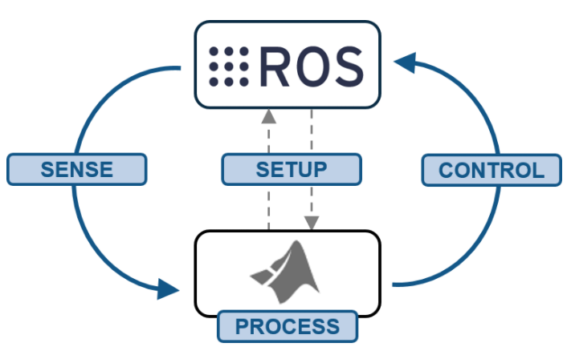

Figure 7: Working diagram of ROS (n.d) [Online]. Available at <https://towardsdatascience.com/what-why-and-how-of-ros-b2f5ea8be0f3/> (Accessed 18 March 2022).

Also, ROS supports many common hardware components such as cameras, LIDARs, and motor controllers. Rather than reinventing the wheel, developers can focus on addressing the problem. ROS packages had over half-billion downloads in 2020 alone, that’s fascinating results. And make ROS an ideal platform not only for organizations but also for a startup (ROS, 2022).

Main programming languages for writing ROS code are C++ and Python, as they are preferred due to better performance. However, there is option to setup ROS for Lisp programming language, if necessary.

Currently, software for ROS primarily tested on Ubuntu and Mac OS X systems with different distributions available. But ROS developers already perform integration on Windows OS. At this moment, there is available option to install ROS on Windows 10 Desktop or Windows 10 IoT Enterprise. Although, ROS provides only limited support for that OS and additionally would require certain prerequisites to be installed first. (ROS, 2022).

The common question robotics developer could ask – “How is ROS different from X?”, where X potentially assumed as another robotics software platform. ROS developers declare, that question to answer straight forward is arguably difficult. The argument point is that as the goal of ROS is not to be a framework with the most features. But instead, the primary goal of ROS is to support code reuse in robotics research and development. ROS is a distributed framework of processes (aka Nodes) that enables executables to be individually designed and loosely coupled at runtime. These processes can be grouped into Packages and Stacks, which can be easily shared and distributed. ROS also supports a federated system of code Repositories that enable collaboration to be distributed as well. This design, from the filesystem level to the community level, enables independent decisions about development and implementation, but all can be brought together with ROS infrastructure tools (OpenRobotics, 2022). Impartially that is strong statement, that allows robotics developers to focus on research and product release in robotics segment. And invest less resources including time and extra costs towards troubleshooting of cohesion between software and hardware aspects. Analogy to this approach can be observed in software development segment. Where containers are used as powerful tool to package and deploy their applications, with focus on distributed resources on innovation and business (AWS.amazon.com, 2022).

It's also worth noting that ROS2 is now available, along with the newest Foxy Fitzroy distribution. As of now, ROS is not widely used in the business, and it lacks some of the most critical features, such as real-time, safety, certification, and security. One of ROS2's objectives is to make it work with industrial applications. There are certainly differences in many elements between both versions, such as ROS2's introduction of the Quality-of-Service feature or ROS2's use of Python instead of XML in authoring launch files (Roboticsbackend.com, 2022). However, future research will concentrate on the distribution of ROS.

## **2.5 GMAPPING**

Simultaneous localization and mapping (SLAM) complexity reduction, discussed before, is a fast-progressing research area. Its attraction is owed to the potential commercial benefits of developing low cost yet highly effective SLAM based robotic applications. One of the first ROS SLAM packages the further research will focus on is ROS Gmapping.

ROS Gmapping package provides laser-based SLAM, as a ROS node called slam_gmapping. Using slam gmapping, a 2-D occupancy grid map (similar to a building floorplan) can be generated using laser and pose data gathered by a mobile robot. The package has been successfully utilized with a variety of ROS-supported robotic platforms.

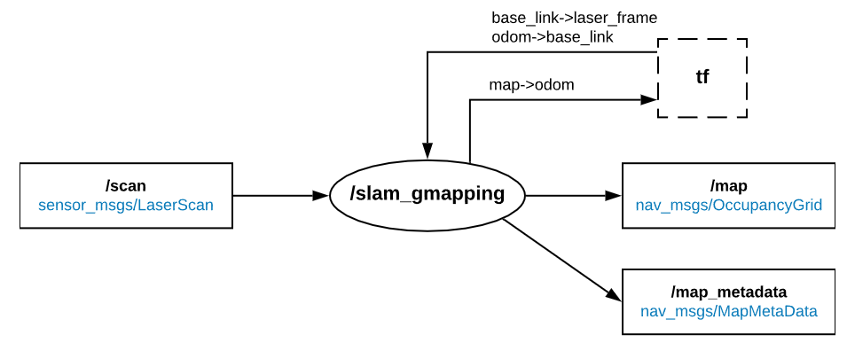

Figure 8: Diagram of Gmapping ROS node structure (n.d) [Online]. Available at <https://www.leorover.tech/guides/autonomous-navigation/> (Accessed 1 May 2022).

Gmapping is based on Rao-Blackwellized particle filters (RBPF) as an effective means to solve the SLAM problem. The working process of the Gmapping can be described in detail further. The Gmapping algorithm can dynamically generate 2D Gmapping by acquiring scanned LiDAR, IMU, and odometer data. Figure 9 provides flowchart of the Gmapping algorithm.

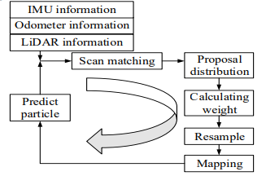

Figure 9: Gmapping algorithm flowchart (n.d) [Online]. Available at <https://iopscience.iop.org/article/10.1088/1742-6596/1237/2/022074/pdf/> (Accessed 2 May 2022).

The robot acquires its surrounding information through the LiDAR, its attitude information through the IMU, and its position information through the odometer; thereby preparing the mapping for the next moment. The RBPF uses the information of observation and sensor output to predict the position and attitude of the particle at the next moment. The scan matching algorithm is performed between the position and attitude of the robot obtained in real time and the position and attitude predicted by the RBPF, thus obtaining the optimal position and attitude of each particle and preparing for particle weight update. According to the optimal position and attitude obtained by scan matching, the particle filter takes several samples around the optimal position and attitude, and its mean and variance satisfy the Gaussian distribution (called the proposed distribution). The weight of each particle is updated and then normalized.

The threshold value is used to determine whether a resampling is required (the threshold value is generally less than 2/3×N, where N is the total number of particles), and the mapping of each particle is updated to complete the SLAM process.

The key idea of the SLAM is to estimate the joint posterior probability density function based on the observed value and sensor output information. The key and difficult problem of the SLAM technology is to complete the functions of simultaneous localization and mapping. The RBPF approach can factor the joint posterior probability density function from a mathematical standpoint. As a result, the RBPF can estimate the robot's location and attitude before mapping it to the known position and attitude. To put it another way, the SLAM concept is turned into the concepts of positioning first and mapping second. According to the mapping's probability density function, the mapping is highly dependent on the robot's position and attitude.

The RBPF algorithm is derived from the Monte Carlo algorithm. The core idea of the RBPF algorithm is to use the weighted sum of a series of random samples to approximate the posterior probability density function. Namely, the probability of an event replaced with the frequency of its occurrence.

However, there are known concerns with the precision of Gmapping. According to the Gmapping concept, the robot's positioning and mapping faults are generated by accumulated odometer errors, significant calculation and memory consumption, particle deterioration, and other error factors and impacts, all of which impair the navigation effect. Numerous particles in the RBPF cause significant calculation and memory usage. Frequent resampling of the RBPF causes particle deterioration (Grisetti, Stachniss and Burgard, 2007).

## **2.6 EXPLORE_LITE**

Furthermore, research will examine and implement another ROS SLAM package. This package is based on greedy frontier-based exploration algorithm. That means when the node is running, robot will greedily explore its environment until no frontiers could be found (Figure 10).

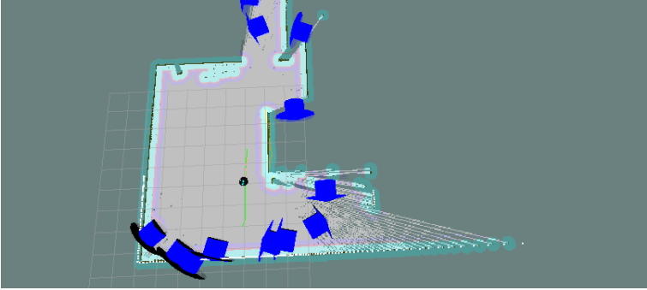

Figure 10: Frontier generated points with respect to robot position (n.d) [Online]. Available at <http://wiki.ros.org/explore_lite/> (Accessed 3 May 2022).

Unlike similar packages explore_lite does not create its own costmap, which makes it easier to configure and more efficient. Node basically subscribes to nav_msgs/OccupancyGrid messages. Thus, leading to those commands for robot movement are send to move_base node. Node can perform fileting and can operate even on non-inflated maps. The blacklisting goal allows to deal with places inaccessible for the robot (ROS, 2022).

Explore_lite uses move_base node for navigation and requires proper configuration of move_base node to be set up. The architecture of the package can be more visibly seen in Figure 11.

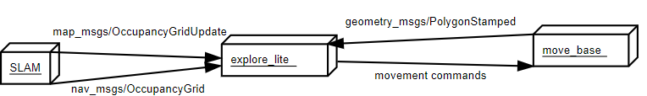

Figure 11: General structure of the explore_lite (n.d) [Online]. Available at <http://wiki.ros.org/explore_lite/> (Accessed 3 May 2022).

ROS explore_lite package was based on previously developed explore package by DuHadway, but originally frontier-based exploration algorithm for an autonomous robot was implemented by B.Yamauchi in 1997 (Yamauchi, 1997).

From that time significant research was developed by Uslu et al. with focus on implementation of frontier-based exploration algorithm in autonomous robot with compatibility of ROS (Uslu et al., 2015). Authors address issue with Gmapping method and how performance can be improved. The main point is, that Gmapping method uses occupancy grid metric model type maps. Occupancy grid enables fusion of different sensor sources and can run smoothly in high resolution grids. However, in large areas as the number of grids increase, calculation cost of Gmapping increases dramatically. That statement was based on Karaoğuz et al. research developed in that segment. (Karaoğuz, Erkent, Bayram and Bozma, 2012). Occupancy of a grid can be defined as the ratio of times that a grid is seen as full to total times of a grid is seen by the sensor. Unexplored areas are initialized with 0.5 as the occupancy value.

In their studies is stated, that frontiers are defined as the border points that happen to lie between explored and unexplored areas which are calculated at the time of mapping and navigation. Navigating to a frontier point enables exploration of unseen areas and adding information to the map. Therefore, sequentially advancing to some next frontier defines the frontier-based exploration.

Allow all points in a known map that can be traversed by a robot to be defined as accessible points. Each reachable point can be defined as neighbor and adjacent, as it is possible to define at least one path that connects the robot start point with any reachable point. In partially known maps it is obvious that previously defined paths should pass through the partially known areas.

It should also be noted, that any path that connects points from partially known area to unexplored areas should pass through a frontier point.Following a path up to several frontiers that connects points from known area to unexplored area each path can be achieved. A robot then can map the entire unexplored area accepting perfect motor control and perfect sensor information. Frontier based exploration guaranties fully mapping of an unknown environment in finite time but with decreasing amount of marginal information as the explored area expands. However, in practice noisy sensor, motor and driving should be taken into account.

Intriguing, that researchers address issue in frontier-based algorithm implementation and prove it is not ideal solution of SLAM problem. The main point is, that, exploration goals cannot be always guaranteed to be as reachable before the robot starts its navigation. Such example is given in Fig. 12 where an obstacle shadow intersects to form a triangular frontier cluster (indicated with yellow lines) and the cluster center (indicated with a red dot) is calculated to be on the obstacle (indicated in blue), yet the robot is unaware of the goal being unreachable throughout its given navigation path. Such situations should be taken into account properly at navigation and exploration levels.

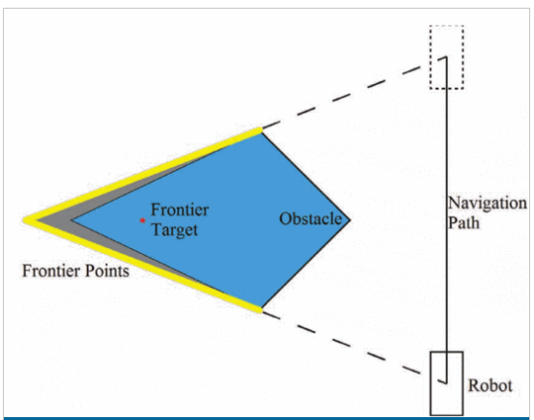

Figure 12: A state where frontier target is calculated on an obstacle.

Lastly, they conclude that in future works, to be able to minimize the revisit to partially explored areas, segmentation-based room extraction is considered. As well as, frontier targets can become explored during the navigation. So, moving the robot to the same frontier target can be considered as loss of time. Also, as a future work, it is considered to recalculate new frontier targets when a previous target becomes explored.

That leaves interesting topic for discussion of Gmapping and Explore_lite performance, as there are completely different methods used and potentially Explore_lite should perform better, however that depends on the environment. Additionally, authors of research leave interesting thesis for future work, that the study that accompanying different frontier target selection approaches, biggest, nearest, random, at some special occasions can decrease the total time of exploration and the total distance of travel.

## **2.7 RRT**

Taking in moderation conclusion of frontier-based authors of explore_lite. Research performed was expanded and included rrt_exploration ROS SLAM package. Package developer H. Umari describes, that it is based on previously discussed frontier-based exploration SLAM algorithm, however it is enhanced with Rapidly-Exploring Random Tree algorithm, what defines whole package name (ROS, 2022).

A Rapidly-exploring Random Tree (RRT) is a data structure and algorithm that is designed for efficiently searching nonconvex high-dimensional spaces. RRTs are constructed incrementally in a way that quickly reduces the expected distance of a randomly-chosen point to the tree. RRTs are particularly suited for path planning problems that involve obstacles and differential constraints (nonholonomic or kinodynamic) and was presented by S. LaValle in 1999. (Lavalle.pl, 2022).

LaValle describes that, the RRT quickly expands in a few directions to quickly explore the four corners of the square (Figure 13).

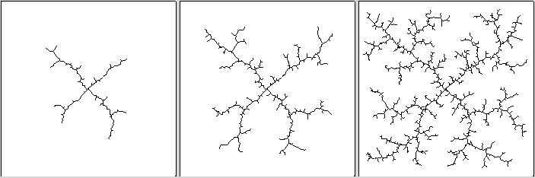

Figure 13: RRT exploration algorithm process in multiple frames. Steve LaValle (n.d)[Online]. Available at <http://lavalle.pl/rrt/about.html/> (Accessed 14 March 2022).

Although the construction approach is simple, finding a strategy that produces such desirable behavior is not easy. Consider a naive random tree, which is built-in steps by selecting a vertex at random, an input at random, and then applying the input to build a new vertex. Although one may anticipate the tree to explore the space at random, there is a substantial inclination toward places that have already been examined. A random walk is likewise biassed toward sites that have already been visited. An RRT by itself is usually insufficient to solve a planning challenge. As a result, it may be thought of as a component that can be used in the creation of a range of different planning algorithms (Lavalle, 2006).

The following is the primary operating principle of RRT for SLAM applications. The RRT package uses the RRT algorithm to path plan to all attainable remote endpoints within the sensor's proximity, called frontier points, causing the robot to continuously map new regions using SLAM as it tries to reach its new distant endpoints (Figure 14). RRT used for mobile robots in this fashion allows for the creation of a self-exploring autonomous robot with minimal human intervention. The algorithm's nature tends to favor uncharted territory, which is advantageous for environmental exploration jobs (Umari & Mukhopadhyay, 2017).

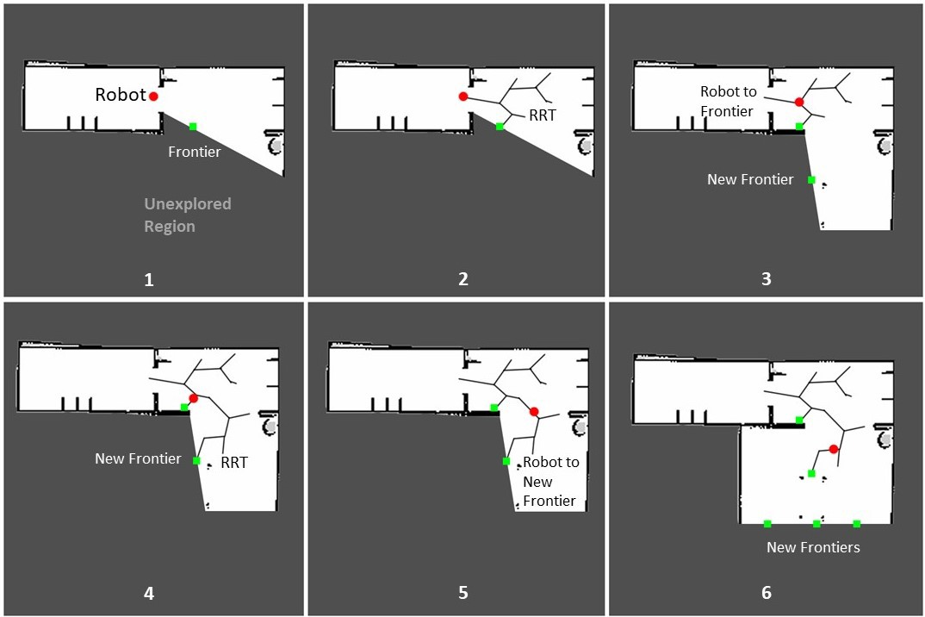

Figure 14: Propagation of RRT Algorithm for exploring unknown environment. Mohamed Fazil, *ROS Autonomous SLAM using Rapidly Exploring Random Tree (RRT)*. January 8, 2021. Available at <https://towardsdatascience.com/ros-autonomous-slam-using-randomly-exploring-random-tree-rrt-37186f6e3568>

(Accessed 14 January 2022).

ROS wiki provides in-depth and detailed information about structure of the RRT package, however more details should be described to the nodes. There are 3 types of nodes; nodes for detecting frontier points in an occupancy grid map, a node for filtering the detected points, and a node for assigning the points to the robots. The following figure (15) shows the structure:

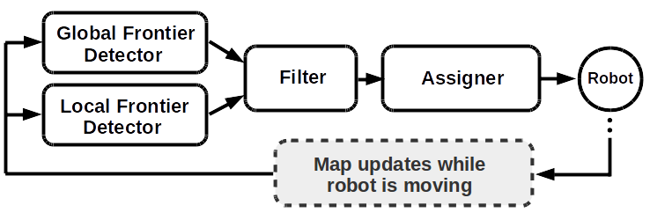

Figure 15: RRT package node diagram. Robotis (n.d). Available at <http://wiki.ros.org/rrt_exploration/> (Accessed 18 March 2022).

global_rrt_frontier_detector

The global_rrt_frontier_detector node takes an occupancy grid and finds frontier points (which are exploration targets) in it. It publishes the detected points so the filter node can process them.

local_rrt_frontier_detector

This node is similar to the global_rrt_frontier_detector. However, it works differently, as the tree here keeps resetting every time a frontier point is detected. This node is intended to be run alongside the global_rrt_frontier_detector node, it is responsible for the fast detection of frontier points that lie in the close vicinity of the robot.

filter

The filter nodes receive the detected frontier points from all the detectors, filter the points, and pass them to the assigner node to command the robots. Filtration includes the selection of old and invalid points, and it also discards redundant points.

the assigner

This node receives target exploration goals, which are the filtered frontier points published by the filter node, and commands the robots accordingly. The assigner node commands the robots through the move_base_node. Which is an essential part of the navigation stack.

Further part of the research will focus on implementing described autonomous SLAM navigation packages by using open-source hardware and software resources. That will allow providing a cumulative reward to the project goal with not only the theoretical part of the research done but also support it with the practical implementation of experiments.

Chapter 3

# **Artefact design**

The artifact is an autonomous mobile robot that can explore an unknown environment and draw a map of the area surveyed with the use of SLAM navigation packages. SLAM algorithm is one of the most commonly studied topics in robotics when it comes to mapping new environments and determining the robot's location and is a fundamental part of the exploration task. And with a variety of open-source SLAM algorithms available, which have proven to be efficient, yet not ideal as their issues.

Therefore, artifact design will be focused on the software aspect, by implementing them and comparing in efficiency. To address navigation issues in exploration, SLAM packages (Gmapping, Explore_lite and RRT) with integrated algorithms will be developed in simulations with the use of the available open-source software simulation tool Gazebo and also in a real environment with the use of the Turtlebot3 Waffle Pi robot model. In such a way artifact design will contribute to open-source robotics and efficient results towards exploration tasks not only in a situation where the environment can be considered ideal but also in complex density one, as many real-world objects have many more parameters to be taken in moderation.

## **3.1 SLAM, Path Planning and Navigation**

Gmapping, Eplore_lite and RRT SLAM navigation algorithms proved to be efficient by work performed by other researchers in literature review. However, to provide measurement in comparison of efficiency to each other, they will be tested in same approach. SLAM helps to generate 2D occupancy grid map from the laser scan data and the mobile robot pose (Figure 16).

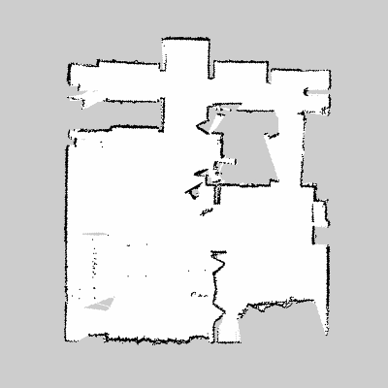

Figure 16: 2D generated occupancy Grid map example (n.d) Available at <https://www.wilselby.com/research/ros-integration/2d-mapping-navigation/> (Accessed 1 May 2022).

Because SLAM algorithms will perform in the same environment in both simulation and real-world circumstances, the major assessment criteria will be how efficiently they accomplish this task in relation to each other. That will include time, accuracy, or any unexpected errors encountered by observation in performance.

Additionally, executing simulations in a virtual environment accelerated artifact development. There are no restrictions on the number of trial runs, and a genuine robot is not required from a hardware standpoint.

Furthermore, due to a variety of causes, the environment in which to test the robot is not always available in a real-world setting, therefore simulation should be considered as an option for other robotics developers with limited resources.

## **3.2 Agile testing methodology**

This project, as well as the artifact development, will follow an agile software development style (Figure 17). An agile software development process provides for continuous testing while development is ongoing, allowing for quick adjustments. Testing will also follow an agile methodology, as the process is agile. Any adjustments that are required to meet the artifact's specifications will be made as the testing is completed.

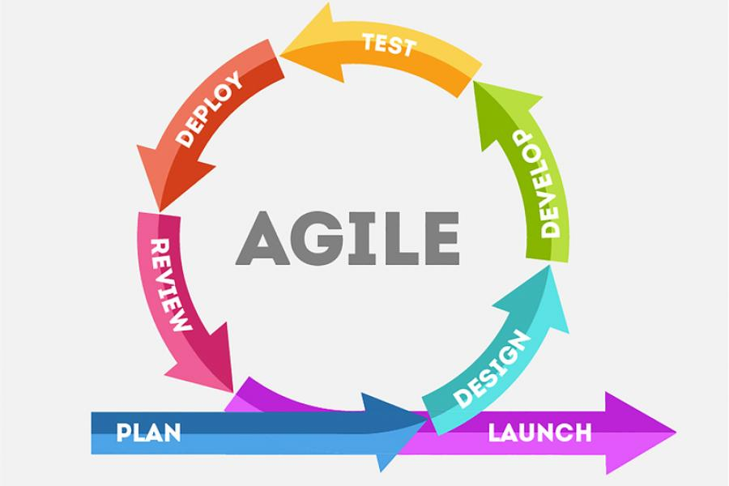

Figure 17: The life cycle of an agile testing approach. Ghada El-Zoghbi, *Why use Agile software development?* 5 May 2021. Available at <https://catalyst-au.net/blog/why-use-agile-software-development/> (Accessed 14 April 2022).

The basic concept is conceived and developed, and it is then continually refined to fulfil the project's and stakeholders' requirements. This construction iteration cycle is repeated until the product's goals for deployment into production are met. Once in production, the project is regularly maintained and supported as needed.

Chapter 4

# **Artefact development**

## **4.1 Gazebo – simulation**

### **4.1.1 Ubuntu and Virtual Machine workstation**

The required software components (ROS) required Linux rather than Windows. Installing Ubuntu 18.04 OS, a modern, open-source desktop operating system based on Linux, provided the solution. While there is a newer version of Ubuntu available, version 20.04 and higher, there have been concerns with other software components running (Ubuntu,2022). This occurred during university laboratory work. My colleague and I got the same instructions for installing the necessary software components. Other tools did not work with Ubuntu 20.04 in his case, although the 18.04 procedure went further.

Ubuntu was also installed on Virtual Machine Workstation 16, allowing for backups and portability due to the limited number of copies made. Instead of installing each environment and software component afresh, a VM workstation enables a large range of configurable hardware configurations that can be duplicated on a USB memory stick and replicated on a laptop. There were, however, certain disadvantages. Because folder sizes ranged from 10GB to more than 10GB, the copying procedure took a long time at first. Second, the allocation of hardware resources between VM and Windows OS had a significant impact on laptop productivity.

The solution was implemented by installing Ubuntu OS as an alternative to Windows OS, which creates a dual-boot option. Where users are freely able to select their preferred OS to run for required tasks. Also, there was no more split between processing resources to supply operations for Windows and VM at the same time. It allowed to dramatically enhance the performance of the software running and should be taken in moderation for users who have limited computations power available, especially for running simulations.

### **4.1.2 ROS**

Robotic Operating System (ROS) is the most essential part of the project from the software point of view. Building a robot might be a complex task as there are many points to consider – motors, sensors, software, and batteries. All these things must work together seamlessly to accomplish the necessary task. ROS is one of the most popular, free, and open-source software that allows simplifying this process. It defines tools, components, and interfaces for building advanced robots. In general, the majority of robots are made up of actuators (things that move), sensors (things that read the world), and control systems (robot’s brain). With the ROS tools topics and messages, developers can build these components faster and easily connect them. These messages can be sent to different kinds of visualization and teleoperation tolls. That allows working with simulated robots or real ones, making the testing and training part more effective. Also, ROS supports many common hardware components such as cameras, LIDARs, and motor controllers. Rather than reinventing the wheel, developers can focus on addressing the problem.

ROS packages had over half-billion downloads in 2020 alone, that’s fascinating results. And make ROS an ideal platform not only for organizations but also for startup robotic developers (ROS,2022).

ROS was included in the university study program and was a necessary component of another assignment. That provided necessary knowledge with the ROS installation and development kit, which further was expanded on my own. The majority of documentation and guidance towards required packages were taken directly from the ROS wiki website or online lectures from ROS developers.

While ROS installation is fairly simple, and many guidelines are available online (including the ROS wiki) as well as in the basement for future software integration, there are a few considerations to consider. ROS, like Ubuntu, has several distribution variants, the most popular of which are Melodic and Noetic. For example, ROS Kinetic ONLY supports Wily because it is based on Debian components used in Ubuntu versions (Ubuntu 15.10). The fundamental advantage of Debian packages over source-based builds is their efficiency. It is strongly recommended that while working with packages, you obtain the package distribution for the same ROS version. Additionally, ROS has created rosdep, a highly efficient command-line tool for installing system dependencies. Setting up an environment or a lack of documentation linked to missing components on open-source materials is a common problem in software development. An analogy may be drawn between attempting to run a python advanced machine learning method written from an external source and receiving an error message stating that a library is missing. This alone introduces completely unneeded troubleshooting challenges as well as inefficient development and resource allocation methods. The Rosdep tool can be used to find and install missing packages that are required by the packages in the catkin workspace (ROS.org, 2022).

Required packages for simulation were installed in catkin_ws/src folder. Which is the standard workspace, alternatively workspace can be created manually. Important to note, that the catkin workspace can be considered similar to Visual Studio, in which simply copying/pasting code won’t work instantly as a system needs to compile code before. In ROS for that purpose is used command catkin_make, compiles packages together and makes them ready to executable afterward. Additionally, it contains a Cmakelist file, which is the input to the Cmake build system for building software packages and contains such essential information as paths to libraries, used nodes, and others. As a text file, it can be manually modified, however, I strongly suggest checking documentation before making any changes in it as a system is very sensitive to information included there (ROS.org, 2022).

### **4.1.3 SLAM and autonomous navigation**

To bring Turtlebot3 into the simulation, it is required to install Turtlebot3 packages. That allows bringing such vital parameters as robot pose, odometry, model, sensor data, and others in the way of executing launch files with nodes of described subscriber and publish topics. But it requires a map containing geometry information to work autonomously. Rviz package allows using 3D GUI to visualize laser scan data from Turtlebot, within its environment. SLAM package includes Rviz and when launched allows that data to create the required 2D grid occupancy map. For that purpose, manual control of teleoperations is needed (Figure 18).

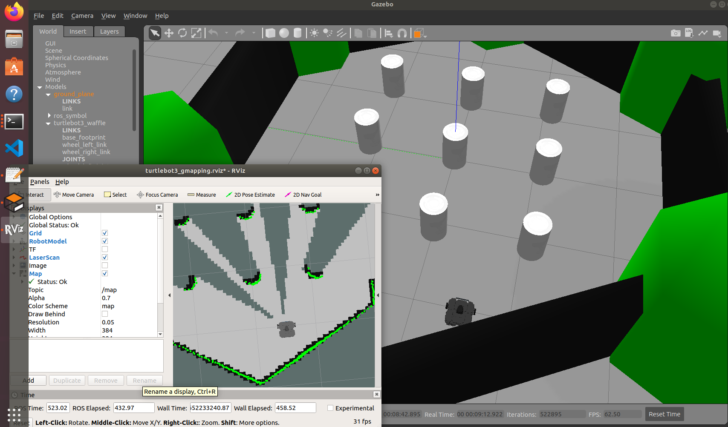

Figure 18: SLAM experiment in Gazebo with Turtlebot3

Once the map is fully or partly created, it is possible to launch the navigation launch file. When the navigation stack is launched the GUI similarly to Figure 16 appears and it is possible to perform a movement by clicking the 2D Nav Goal button (Figure 19).

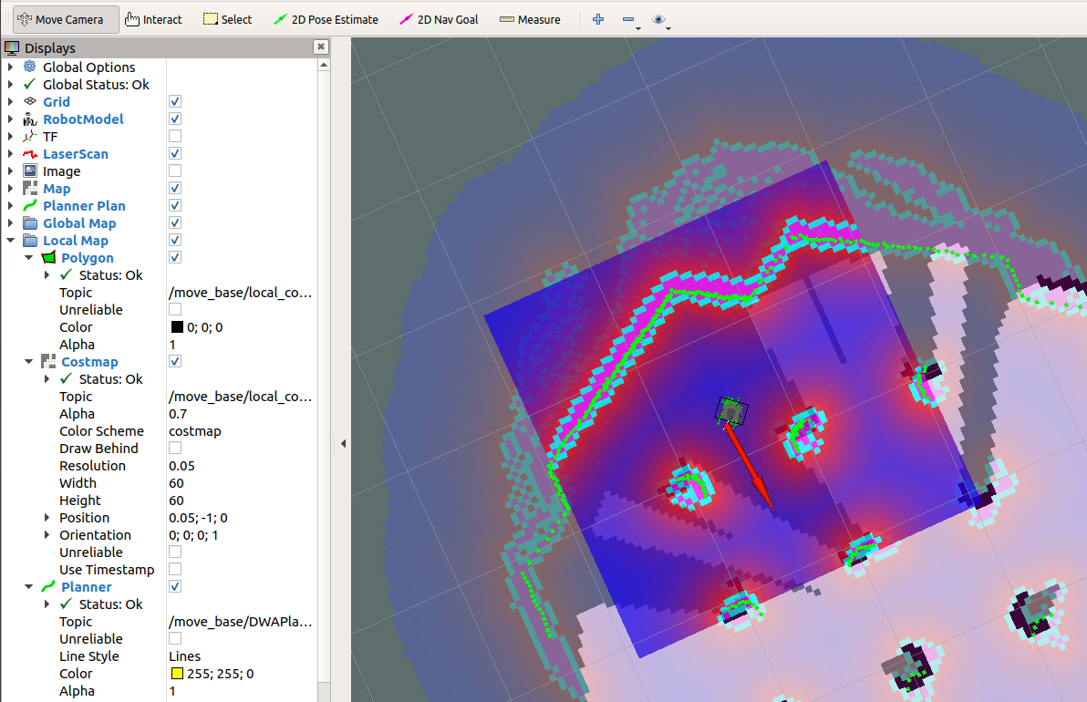

Figure 19: Navigation stack experiment with corrected pose after movement

Navigation package using the /move_base node to perform Turtlebot movement within simulation in the direction of navigation goal vector.

Additionally, Rviz GUI has multiple options of topics to be observed and their parameters. For example, it is possible in the LaserScan topic to configure generated point cloud density by changing the value of point size. Or visualize the TF of the robot, which stands for transform tree and allows to take into consideration odometry in SLAM (Figure 20). TF sends X, Y, and Z-axis data from the wheel encoders, and since wheels rotate, their position in the environment changes too, which allows for calculating distance traveled.

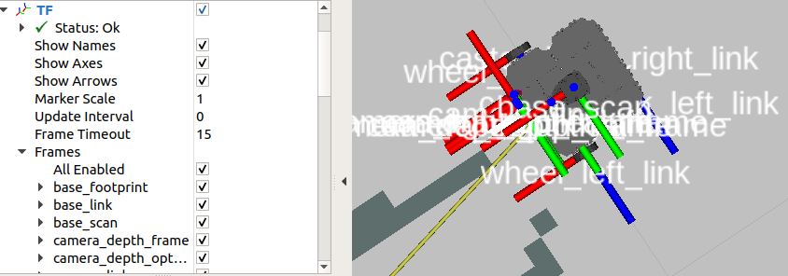

Figure 20: Turtlebot3 waffle_pi model transfer tree (TF) visualization in Rviz.

Information provided in this section included artifact development and images of the SLAM node, where Gmapping is used as a default SLAM method (Robotis, 2022) for software experiments. Afterward were installed Explore_lite and RRT packages without any major differences and allowed to do performance tests for all three SLAM navigation packages which will be discussed in detail in the next chapter.

## **4.2 Turtlebot3 – prototype**

Equally important to artefact development to further address exploration issues with navigation, using SLAM different algorithms and perform their comparison in performance they will be tested within real world environment with use of Turtlebot3 waffle Pi. That also allows to further expand project borders related to project scope.

### **4.2.1 Hardware**

Turtlebot3 (TB) is developed by ROBOTIS and comes with documentation to assemble it or either can be review online on their website (Robotis, 2022). TB was already assembled, as it was used for previous UoB student for his project. However, that should not exclude the part of hardware documentation, since due to circumstances explained further it was required to get access to middle layer of its structure where single board computer (Raspberry Pi 3), embedded board and other modules located (Figure 21).

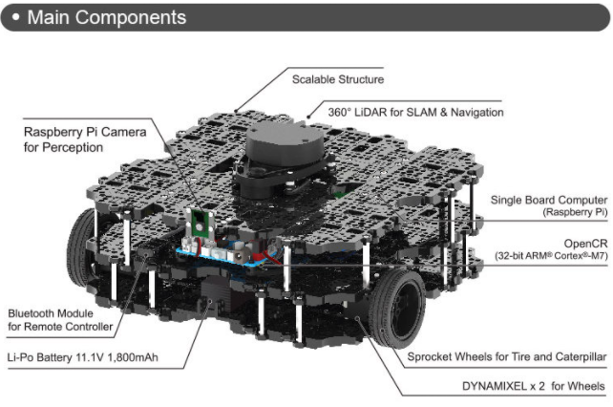

Figure 21: Fully assembled – 3-layer TurtleBot waffle Pi. Generation Robots (n.d) [Online]. Available at <https://www.generationrobots.com/en/402886-turtlebot3-waffle-pi.html/> (Accessed 19 April 2022)

Due to fact that further part of development requires software to be installed in Raspberry Pi and memory card slot, which contains OS, is being having restricted physical access. It is strongly advised in future to firstly assemble TB till layer two and perform all the necessary software installation with testing and afterwards to assemble layer three (Figure 22). Additionally, to perform software installation and updates with Raspberry Pi there is need for HDMI cable and monitor connected with SBC. There was also issue encountered with Lipo battery and since cable power supply connection would limit operating range and also would affect wheel encoders. Battery was replaced with similar one, with difference in capacity from 1800mAh to 5200mAh.

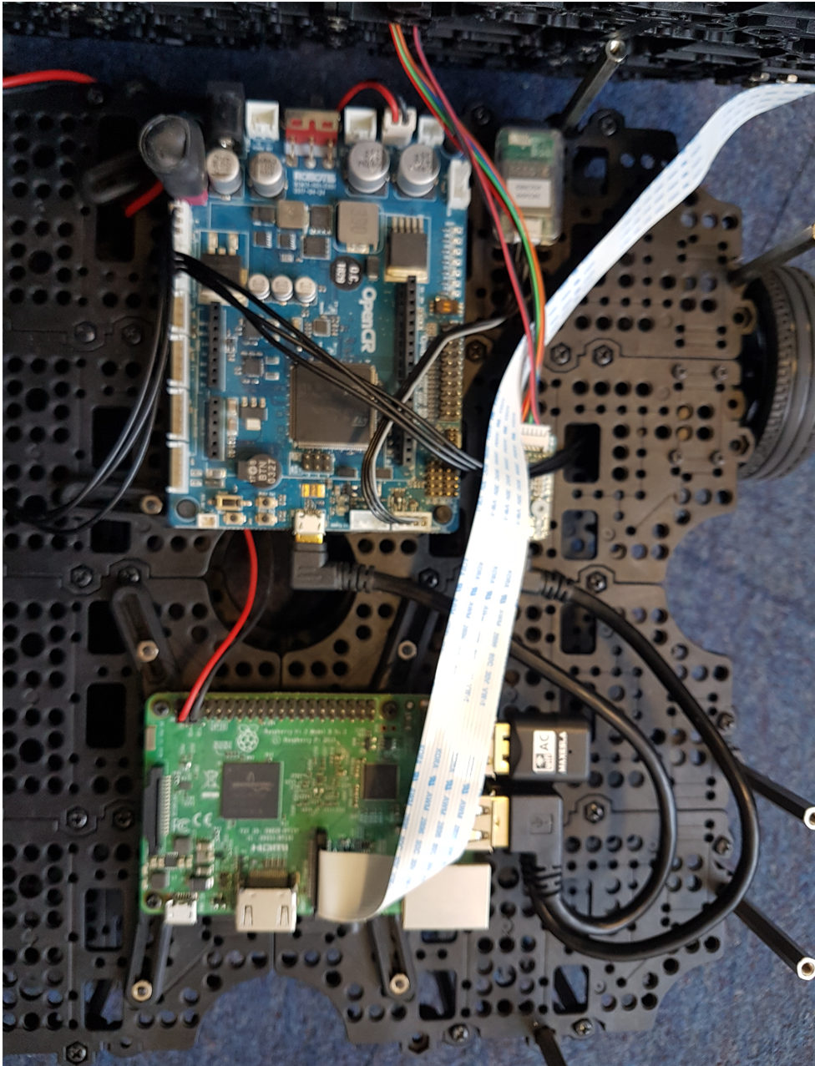

Figure 22: Turtlebot3 layer two – top view

### **4.2.2 Network configuration**

Wifi setup required network configuration to be done on both devices – Turtlebot3 and Laptop. ROS master will be implemented on Laptop and Turtlebot3 will be host (Figure 23).

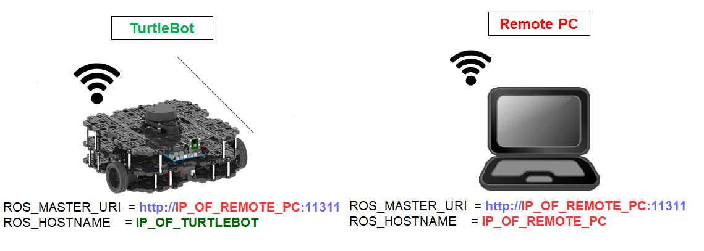

Figure 23: Network connection IP address configrutation for Turtlebot3 and Laptop. Robotis (n.d)[Online]. Available at <https://emanual.robotis.com/docs/en/platform/turtlebot3/quick-start/> (Accessed 17 April 2022).

The IP address within current network, assuming WiFi connection is working can be achieved by using ifconfig command in terminal on both devices.

There was issue encountered with this part. To match ROS Melodic distribution on laptop device, Melodic image containing OS was downloaded from Robotis website (Robotis, 2022). However, OS was not able to detect WiFi module and therefore lead to inability to set up network connection on Turtlebot3. Interesting solution was discovered by installing not Melodic distribution image on Turtlebot3, but Kinetic. In general, that leads to distribution version mismatch and potentially should produce issues with packages used between both devices. My assumption is, that both distributions use same packages for Turtlebot3 publisher/subscriber topics and designed nodes. However, it should be taken in moderation if configuration takes in-depth approach.

Another issue was encountered with date synchronization on Raspberry Pi3. Due to time of data what is being published by Turtlebot3 and ROS master subscribed topics on laptop not being within same timeframe, that lead to inability to use SLAM from laptop. Analogy to this issue can observed from a point of using mobile phone or either smartwatch as device to get information about time now. If device is not synchronized within current time, it will produce incorrect information, which is essential for actions we would consider based on that. Synchronization should be done by using data from Network Time Protocol (NTP) server, however access to connect to them and use that data was restricted within UoB network, due to safety protocol configuration reasons. Also, there was no difference in using mobile hotspot or trying to connect to other NTP servers (including Google or Ubuntu) as routing protocols on the end point restrict access anyway. In order to resolve this issue IT department could be contacted, which could open port slot for specific NTP server. Or manually setting up date and time, when connected to Raspberry Pi. However, that would take additional time and potentially issue could be encountered within other network, what would make solution redundant. Creative solution been found by using network traceback script (RaspberryPi, 2022).

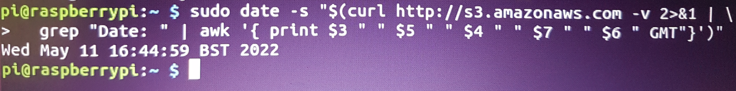

Figure 24: Traceback script with Amazon AWS server connection.

Script allows check data of in this example, Amazon AWS server with internet connection (Figure 24). But it does not run NTP part, this might be considered as not the best solution if Raspberry Pi is running continuously all the time. Additionally, on each instance of Raspberry Pi login connection it should be used. This is flexible option, but requires one additional line of code to be used before starting Turtlebot3.

### **4.2.3 Software wrap-up and Turtlebot3 launch**

All of the ROS software described with Gazebo simulation was installed on a laptop. When appropriate networking configuration, software, and hardware parts were installed and set up using ROS, an experimental launch was accomplished (Figure 25).

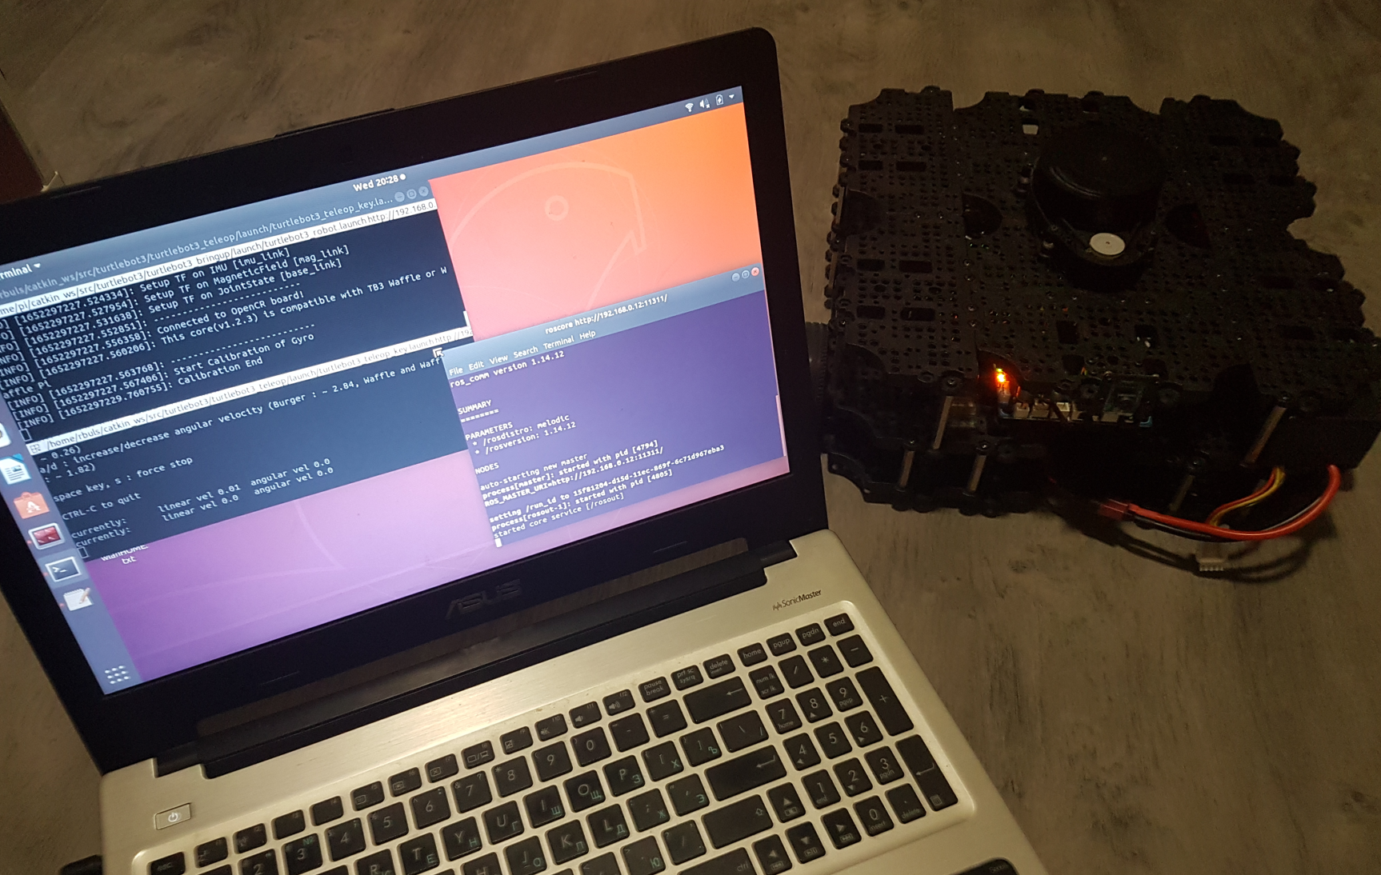

Figure 25: Turtlebot3 teleoperations experiment

Compared to simulations, in this instance real Turtlebot3 will be used – launch setup is different. Firstly, identical to simulation part, roscore should be launched within terminal. That allows to bring collection of nodes and programs that are pre-requisites of a ROS-based system (ROS, 2022). It is necessary part of the ROS to provide ability for nodes to communicate within each other, also it includes node communication between Turtlebot3 and ROSmaster server on laptop, where IP address is stated (Figure 26). Important to note, that roscore node should be running to maintain node interface ability within each other (ROS, 2022).

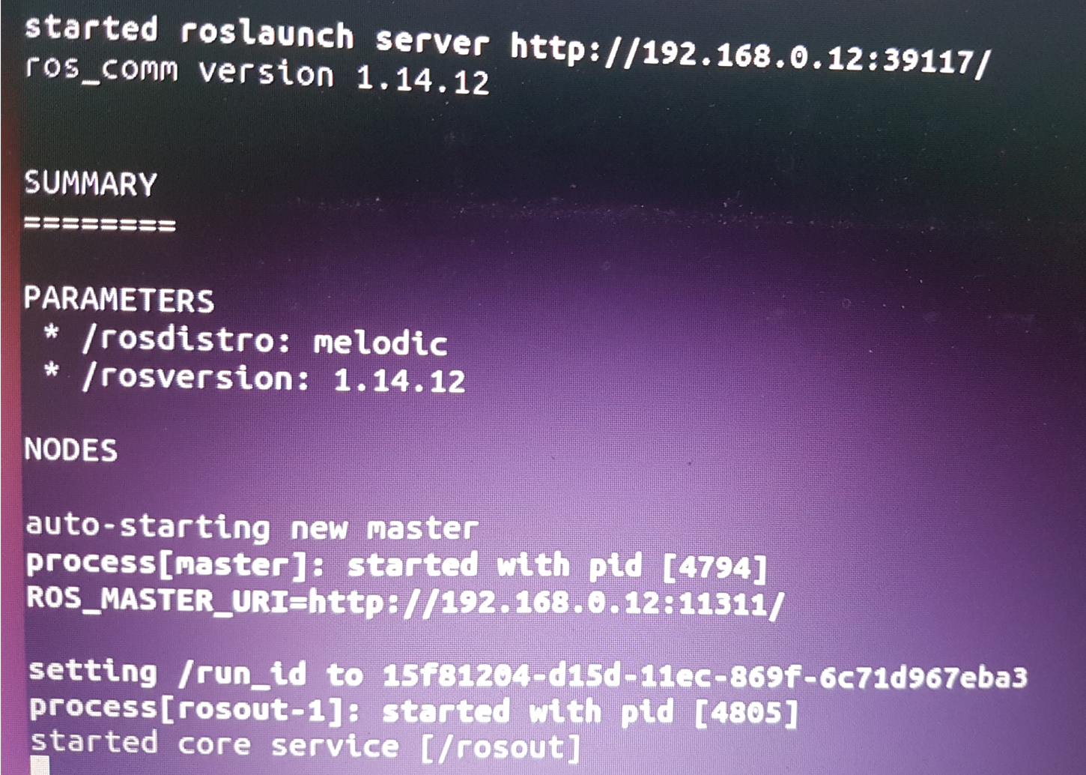

Figure 26: roscore command provided information

Afterwards, assuming Turtlebot3 is turned on, secure shell (SSH) connection to Turtlebot3 being used to remotely log in Turtlebot3 OS, where ROS is located. Within that terminal is being used, previously mentioned script command to synchronizes date/time. Turtlebot3 applications are started with launch file (Robotis, 2022). Turtlebot3 performs diagnostics, calibrations and runs required nodes for ROSmaster communication on laptop. Lastly, required packages can be executed for SLAM navigations algorithms, similarly to Gazebo simulation.

Occasionally “Failed to get param” error occurs. Which indicates timeout between Raspberry Pi and OpenCR (Figure 27). However, this problem can be easily resolved by starting launch file again (ROS, 2022).

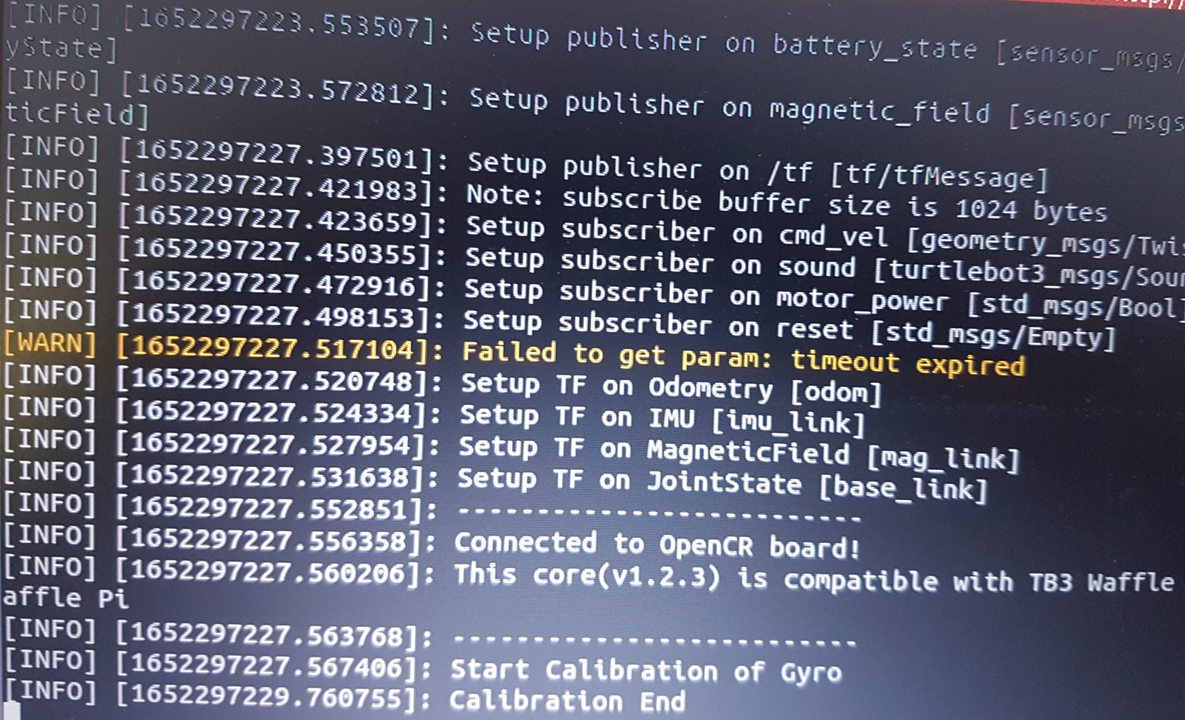

Figure 27: Encountered param error

Chapter 5

# **Testing, Results & Evaluation**

This section will reiterate objectives as main goal for experiments performed. Test the predicted features and highlight issues encountered. This enables evaluation based on the outcomes to be discussed.

* Development – This objective requires Gmapping, Explore_lite and RRT packages to be installed and set for exploration task.
* Exploration – This objective requires Turtlebot3 to operate within unknown environment and draw map of the area.
* Efficiency – This objective will

## **5.1 Gazebo – simulation**

### **5.1.1 Testing**

Experiments will be performed on the Gazebo House map (Figure 28). That allows simulating complex and large unexplored environment, compared to the Gazebo World map. The map contains multiple rooms and objects. The middle part of the map with open door next to blue marker location is not included in the design part. Quick tests showed that Rviz and SLAM behavior within that location completely fails simulations and should be taken in moderation, when question rises about unexplored area of that place.

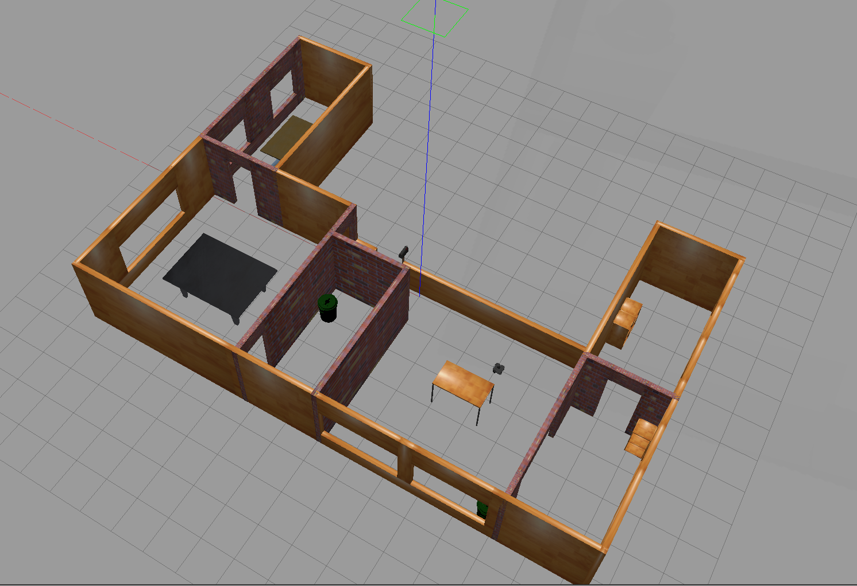

Figure 28: House map from Gazebo simulation tool

Four iterations of the same SLAM packages will be utilized, with the following criterion parameters:

* Time – operation time of the SLAM package to fully explore area or until failure. Measured in minutes/seconds
* Failure – if Turtlebot3 encountered error for the exploration task
* Reason – cause of error
* Comeback – if recovery procedure was available
* Comeback method – tools used for recovery process (teleop, package reboot)
* Map generated – Indicates coverage of the explored area in comparison to model. Measured in percentages
* Alternative path planning – Related to factual world experiments, where obstacle was blocking pathway, however there was alternative route to avoid it. This indicates if robot was actually using alternative with respect to robot.

### **5.1.2 Results**

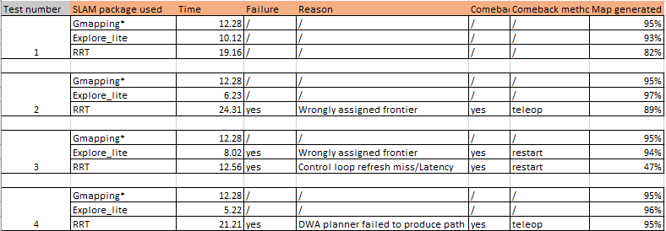

Table 1: Gazebo simulation results including Gmapping teleop.

Gmapping* - SLAM for Gmapping was tested by doing teleop to replicate behavior of robot. Autonomous navigation is possible with navigation stack, but it fails without SLAM created map before or provides unacceptable grid map. If quality of map aspect is excluded, that Gmapping autonomus exploration operated with same results listed in sections for Time and Map generated, with minor difference in time.

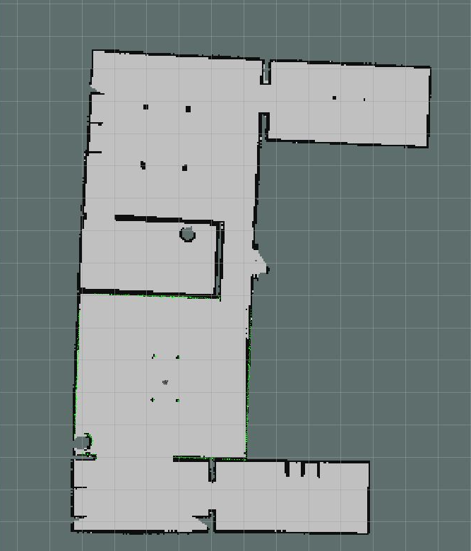

Figure 29: Explore_lite produced map with minimal unexplored spaces.

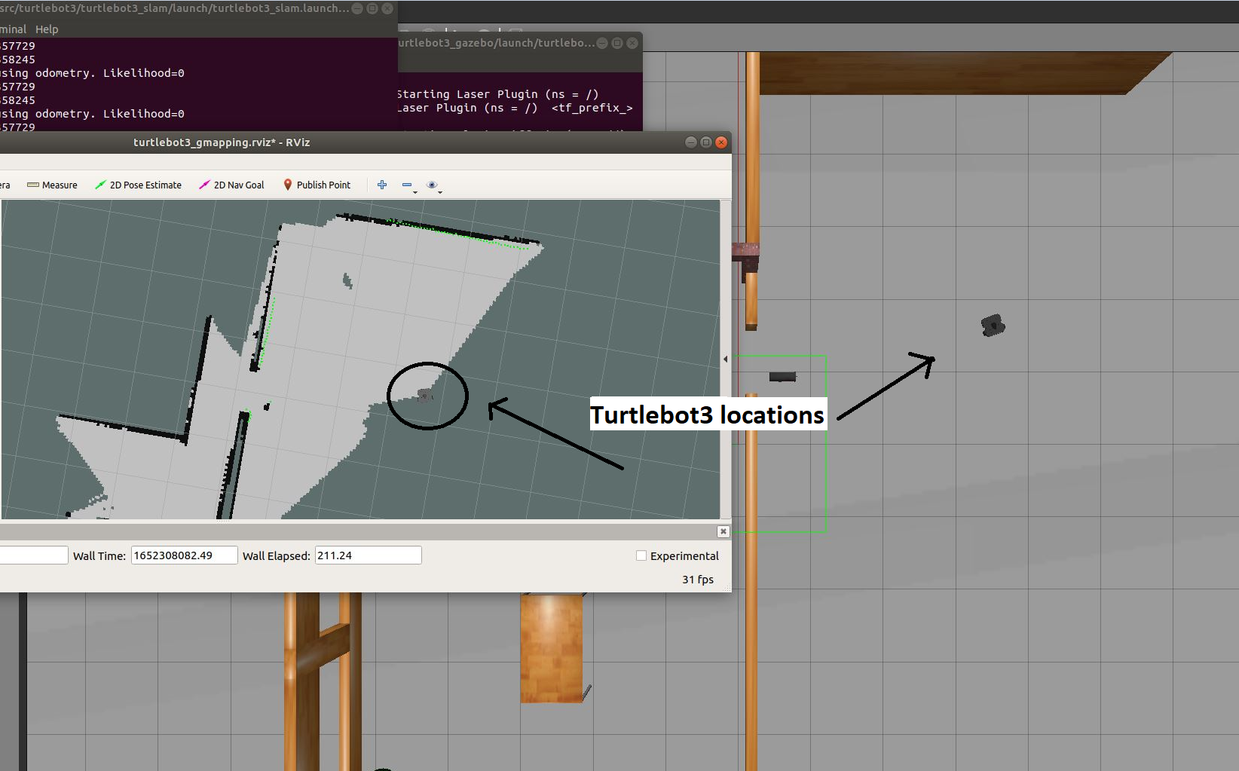

Figure 30: Gazebo House map error area for all SLAM packages

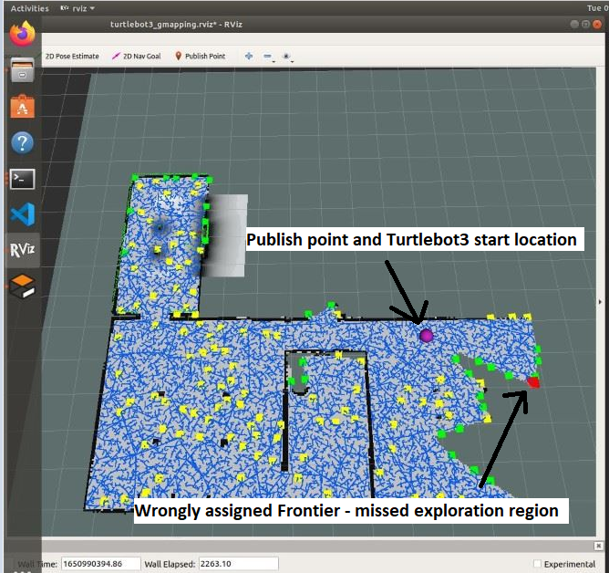

Figure 31: RRT wrongly assigned error example

### **5.1.3 Evaluation**

The software implementation for the Gazebo simulation was fairly simple to do, as it was a matter of combining packages available in open-source access and following documentation attached for each. Additional information was acquired from ROS developers on the ROS website and online lectures. Simulation experiments were very effective for each SLAM package tested.

That allowed to address issues encountered and review various performance aspects since SLAM packages use different methods to operate. Explore_lite and RRT have the feature to be fully autonomous when launched, however, in the results list, there was user interaction required to fix the error. The biggest difficulty was to review Gmapping performance. The way how it operates makes statement of autonomous exploration questionable. Additionally, multiple experiments were done. With conditions of operating without pose corrected or minimal map is created for navigation stack, to try bring element of unknown surroundings. In these cases, major errors took a place on the start of experiments and lead to unrecovered failure. In many instances both RRT and Explore_lite were able to perform task on required level, however RRT needs more attention and tend to have often issues with frontier assigned values. Failures that occurred allowed for concerns to be addressed further in experiments with Turtlebot3 in non-simulation environment.

## **5.2 Turtlebot3 – factual environment**

### **5.2.1 Testing**

Based on simulation results majority of issues took a place of wrongly assigned frontier. Moreover, that error in most cases appeared in the middle of House map blue marker part (Figure 26). For this purpose, for factual environment living room was selected as unexplored environment.

With a table object in the middle, it allowed to replicate narrow space and perform tests related to that issue (Figure 32). Also, experiment 3B included adding obstacle object in not yet explored space to implement alternative path planning factor. In experiment 4M, object was not static and after it was detected and alternative navigation was established, it was removed (Table 2).

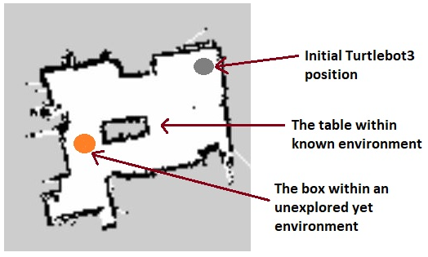

Figure 32: Factual environment Grid map with legend.

### **5.2.2 Results**

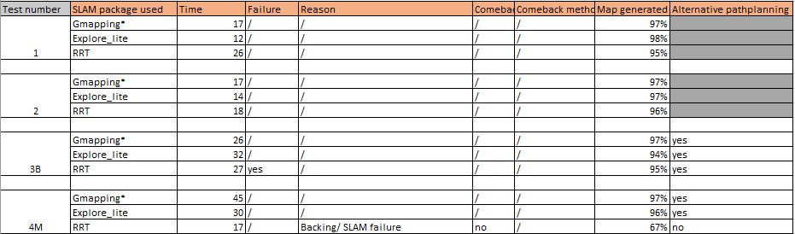

Table 2: Factual environment test results, with additional measurement values

Gmapping* - Experiments 3 and 4 were applied to Gmapping navigation, to performance tests from perspective of path planning.

### **5.2.3 Evaluation**

The major part of artifact development from the software and hardware aspect was related to performing desired experiments within the factual environment. During this part, numerous troubleshooting issues were encountered, which required a dedicated approach for resolution. That allowed to dramatically increase the scope of the project and knowledge in autonomous robotics development with ROS and Turtlebot3.

The biggest difficulties encountered were related to networking and software parts. Even with guidance provided by external sources, the solution was not working as expected in this instance. That required alternative options to be implemented, which affected the time of the development and implementation.

The experimentations done, allowed to address SLAM navigation issues even further from simulation tests. Additional challenges were added, including static and opposite to that unexplored obstacle. That included to demonstrate intelligence level of the robot by resolving problem with alternative path navigation. Across all experiments, Explote_lite showed the best performance.

Chapter 6

# **Future Work & Conclusion**

## **6.1 Future Work**

This project could be improved further in order to make the exploring task of an unknown environment more effective and efficient.

* The current SLAM packages and their respective methods used for this project can be enhanced by manually changing values of many parameters used. For example, AMCL parameters in transform tolerance node can be adjusted to reduce delay in the controller loop. That could potentially increase performance of RRT
* Project was limited to three SLAM packages, but there is variety of other open-source options, which will able to produce different results. For instance, Google cartographer.
* Combination of SLAM methods can take a place too. Gmapping performance can be increased by enhancing with Firefly algorithm.
* LiDAR based SLAM used in this project alternatively can be replaced with Visual SLAM, or combination of both of them. Where camera and laser will operate together. This research topic, on the other hand, would constitute a project in and of itself.

## **6.2 Conclusion**

This project focused on the research and development of an autonomous exploration robot within an unknown environment and addressing the main issues in the problem of performing this task effetely. The introduction part presents the main objectives and aims set to be achieved for this project. The aim is to develop an autonomous exploration robot “Pathfinder” with available open-source software and hardware. The objectives provide a summary of relevant research this project was focused on; develop a SLAM-based software solution for exploration tasks; Construct the Turtlebot3; develop improvement for SLAM-based software to achieve autonomous and efficient exploration. A quantitative approach was taken for the research of this project. The scope focused on the research of SLAM methods used and their issues for autonomous exploration robots. The literature review was limited to LiDAR SLAM solutions and their availability within an open-source segment.

The literature review describes SLAM's importance in navigation aspects. The significance of ROS in a robotics development platform that is open-source. SLAM-based solutions for autonomous exploration task, their operation algorithms, and working structure in ROS. Which will be used for integration in the Turtlebot3 Waffle Pi robot model.

The artifact design section discusses the plan for the software and hardware development in the simulation tool Gazebo and Turtlebot3 Waffle Pi. Justification of artifact design and contribution towards exploration problem faced.

The artifact development provides detailed information on software and hardware implementation and reasons for actions and decisions. Keen attention to issues encountered and used solutions for the project progression allows to benefit robotics developers with similar open-source projects and in future projects.

The testing, results & evaluation segment covers the part of experiments used in simulation tools and real environments for autonomous exploration. Performance parameters are used extensively, yet accurately evaluate the results of each SLAM navigation package used and their efficiency.

In conclusion, the main aim and objectives were successfully achieved. The “Pathfinder” robot can explore unknown environments on a fully autonomous level from the start with a certain level of limitations. But, none of the SLAM solutions developed to provide ideal results, what is acceptable due to the nature of the performance of algorithms and their imperfect calculations, what should be taken in moderation for further decisions robot is computing concerning latency delay and many other parameters. This statement indicates the main problem – There is yet no perfect solution, and the issue is still wide open for research and topics to discuss, however, improvements are available and should be used to improve the effectiveness of autonomous robots, as hardware resources are limited.

# **List of references**

1. Boston Dynamics 2022, *“Spot” product*, Boston Dynamics, viewed 3 April 2022,

< <https://www.bostondynamics.com/products/spot>>

2. Anybotics 2022, *Anymal robot*, Anybotics, viewed 22 March 2022,

<<https://www.anybotics.com/anymal-autonomous-legged-robot/>>

3. ROBOTIS 2022, *TurtleBot3 features*, ROBOTIS, viewed 14 April 2022,

< <https://emanual.robotis.com/docs/en/platform/turtlebot3/features/#specifications>>

4. Choset, H., Lynch, K.M., Hutchinson, S., Kantor, G.A. and Burgard, W., 2005. *Principles of robot motion: theory, algorithms, and implementations*. MIT press.

5. Gul, F., Rahiman, W. and Nazli Alhady, S.S., 2019. A comprehensive study for robot navigation techniques. *Cogent Engineering*, *6*(1), p.1632046.

<<https://www.tandfonline.com/doi/full/10.1080/23311916.2019.1632046>>

6. Hassani, Imen & Maalej, Imen & Rekik, Chokri. (2018). Robot Path Planning with Avoiding Obstacles in Known Environment Using Free Segments and Turning Points Algorithm. Mathematical Problems in Engineering. 2018. 1-13. 10.1155/2018/2163278. <<https://www.researchgate.net/publication/325717736_Robot_Path_Planning_with_Avoiding_Obstacles_in_Known_Environment_Using_Free_Segments_and_Turning_Points_Algorithm>>

7. Ibraheem, Ibraheem & Hassan Ajeil, Fatin. (2018). Path Planning of an Autonomous Mobile Robot in a Dynamic Environment using Modified Bat Swarm Optimization. 10.13140/RG.2.2.33381.50409.

<<https://www.researchgate.net/publication/326450172_Path_Planning_of_an_Autonomous_Mobile_Robot_in_a_Dynamic_Environment_using_Modified_Bat_Swarm_Optimization>>

8. Alajlan, M., Koubaa, A., Chaari, I., Bennaceur, H. and Ammar, A., 2013, December. Global path planning for mobile robots in large-scale grid environments using genetic algorithms. In *2013 International Conference on Individual and Collective Behaviors in Robotics (ICBR)* (pp. 1-8). IEEE.

< <https://ieeexplore.ieee.org/abstract/document/6729271>>

9. Soltani, A.R., Tawfik, H., Goulermas, J.Y. and Fernando, T., 2002. Path planning in construction sites: performance evaluation of the Dijkstra, A∗, and GA search algorithms. *Advanced engineering informatics*, *16*(4), pp.291-303.

<<https://doi.org/10.1016/S1474-0346(03)00018-1>>

10. Alija, A.S., 2015. *Analysis of Dijkstra's and A* Algorithm to Find the Shortest Path* (Doctoral dissertation, Universiti Tun Hussein Onn Malaysia).

< <https://1library.net/document/qmwrxo7z-analysis-dijkstra-s-algorithm-shortest-path.html>>

11. ROS 2021, *base_local_planner*, Open robotics, viewed 23 January 2022,

<http://wiki.ros.org/base_local_planner>

12. Brian Douglas (2020), Understanding SLAM Using Pose Graph Optimization | | Autonomous Navigation, Part 3, MATLAB, viewed 5 February 2022,

< <https://www.youtube.com/watch?v=saVZtgPyyJQ>>

13. ROS 2021, What is ROS, Open robotics, viewed 23 January 2022,

< <http://wiki.ros.org/ROS/Introduction>>

13. Amazon 2022, AWS, viewed 31 March 2022,

<<https://aws.amazon.com/ru/getting-started/deep-dive-containers/>>

14. Yamauchi, B., 1997, July. A frontier-based approach for autonomous exploration. In *Proceedings 1997 IEEE International Symposium on Computational Intelligence in Robotics and Automation CIRA'97.'Towards New Computational Principles for Robotics and Automation'* (pp. 146-151). IEEE.

< <https://ieeexplore.ieee.org/abstract/document/613851>>

15. E. Uslu, F. Çakmak, M. Balcılar, A. Akıncı, M. F. Amasyalı and S. Yavuz, "Implementation of frontier-based exploration algorithm for an autonomous robot," 2015 International Symposium on Innovations in Intelligent SysTems and Applications (INISTA), 2015, pp. 1-7, doi: 10.1109/INISTA.2015.7276723.

<<https://ieeexplore.ieee.org/abstract/document/7276723>>

16. G. Grisetti, C. Stachniss and W. Burgard, "Improved Techniques for Grid Mapping With Rao-Blackwellized Particle Filters," in IEEE Transactions on Robotics, vol. 23, no. 1, pp. 34-46, Feb. 2007, doi: 10.1109/TRO.2006.889486.

< <https://ieeexplore.ieee.org/abstract/document/4084563>>

16. H. Karaoğuz, O. Erkent, H. Bayram and H. I. Bozma, "Tek Robottan coklu Robotlara Ortam Haritalama", EMO Bilimsel Dergi, vol. 2, no. 4, pp. 105-118, 2012.

< <https://dergipark.org.tr/en/pub/emobd/issue/5505/74664>>

17. Steve LaValle, *About RRTs,* viewed at 22 March 2022,

<<http://lavalle.pl/rrt/about.html>>

18. Steven M. LaValle, 2006. *Planning Algorithms*, Cambridge press.

< <http://lavalle.pl/planning/book.html>>

19. H. Umari and S. Mukhopadhyay, "Autonomous robotic exploration based on multiple rapidly-exploring randomized trees," 2017 IEEE/RSJ International Conference on Intelligent Robots and Systems (IROS), 2017, pp. 1396-1402, doi: 10.1109/IROS.2017.8202319.

< <https://ieeexplore.ieee.org/document/8202319/authors#authors>>

20. Will Selby, (n.d), *2D Mapping and Navigation*, Will Selby,

<<https://www.wilselby.com/research/ros-integration/2d-mapping-navigation/>>

21. Ghada El-Zoghbi, 2021. *Why use Agile software development?* Catalyst IT Australia.

<<https://catalyst-au.net/blog/why-use-agile-software-development>>

22. Canonical, *Ubuntu*, Canonical Ltd.,

<ubuntu.com>

23.ROBOTIS, Turtlebot3 waffle PI, ROBOTIS Inc.,

< <https://www.robotis.us/turtlebot-3-waffle-pi/>>

24. ROBOTIS. [*ros 1] navigation*, ROBOTIS Inc.,

<<http://emanual.robotis.com/docs/en/platform/turtlebot3/navigation/#ros-1-navigation.>>

25. ROBOTIS. *Turtlebot3 specification*, ROBOTIS Inc.,

<<http://emanual.robotis.com/docs/en/platform/turtlebot3/specifications/#specifications>>

26. Generation Robots, *Turtlebot3 Waffle Pi*, Generation Robots Ltd, 2022,

<<https://www.generationrobots.com/en/402886-turtlebot3-waffle-pi.html>>

27. RaspberryPi, *How to sync clock on raspberry pi with restricted internet traffic*, Stack Exchange Inc, 2022.

<<https://raspberrypi.stackexchange.com/questions/117974/how-to-sync-clock-on-raspberry-pi-with-restricted-internet-traffic>>

28. ROS, *roscore*, Open Robotics Ltd, 2022,

<<http://wiki.ros.org/roscore>>

# **Appendices**

## **Appendix A – Turtlebot3 Hardware**

Turtlebot3 was already assembled from previous student. However, in aspects related to hardware and software integration and assembly all the material was related to – Emanual.robotis.com. But it is important to highlight hardware specifications of Turtlebot3 Waffle Pi model

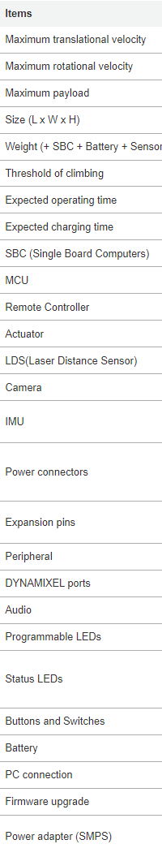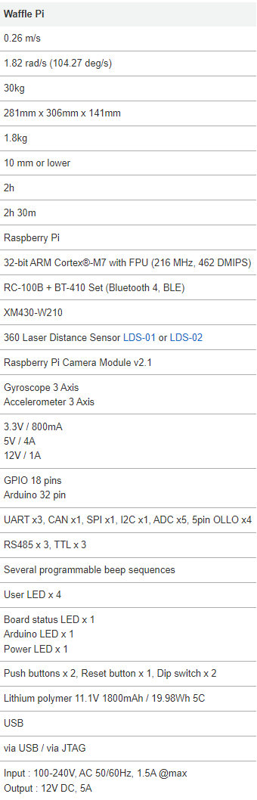

Figure 33: Full list with details of Turtlebot3 hardware components.

## **Appendix B – Additional testing results**

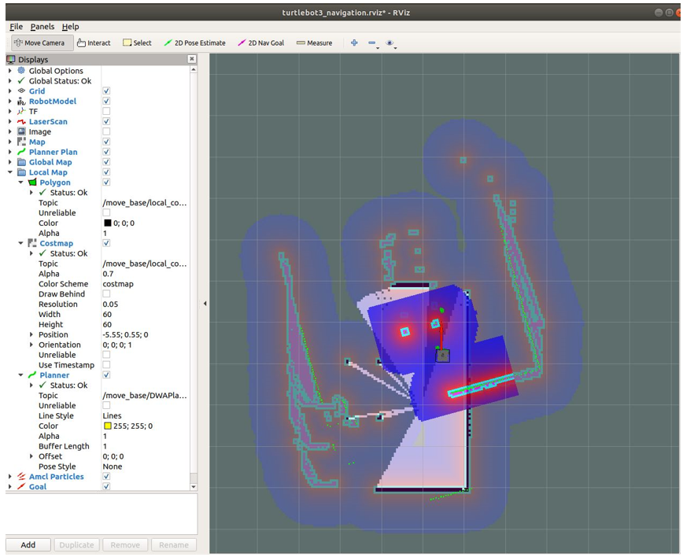

Figure 34: Gmapping navigation stack launch with failed pose

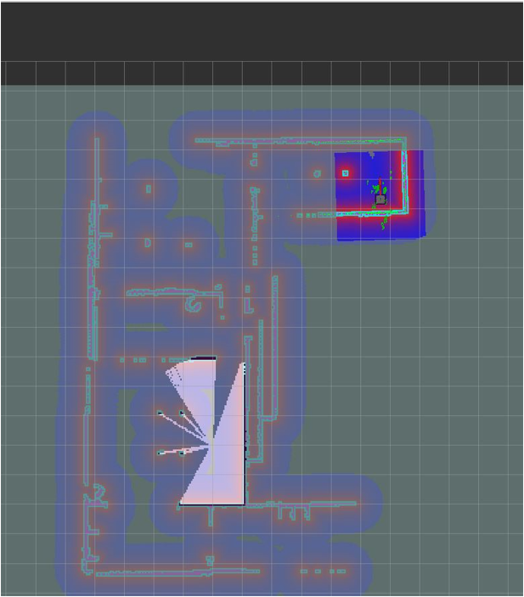

Figure 35: Gmapping navigation without SLAM created map – Autonomous with 2D nav goal. Map created with TB3 magnetic field.

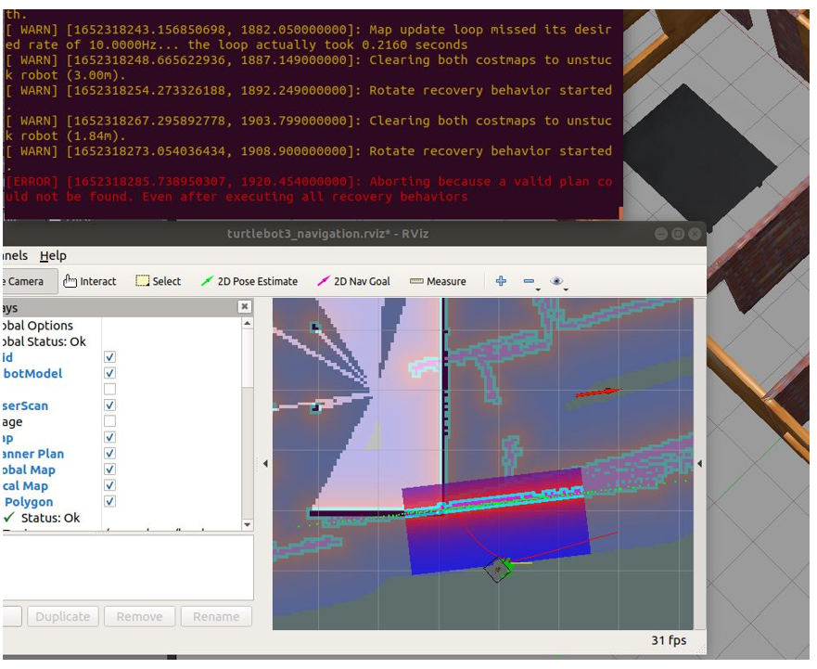

Figure 36: Gmapping Error within unknown environment, including recovery procedures.

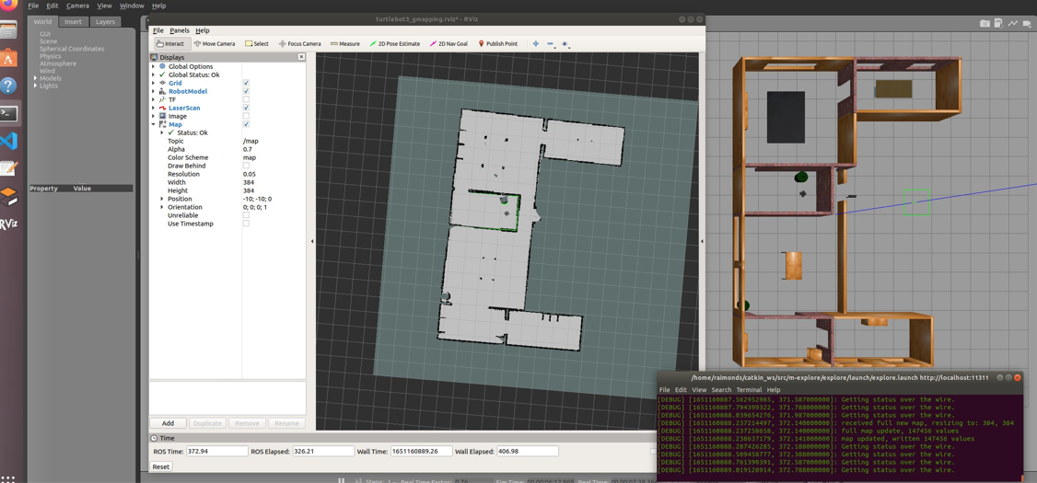

Figure 37: Explore_lite fully autonomous SLAM success of complete map.

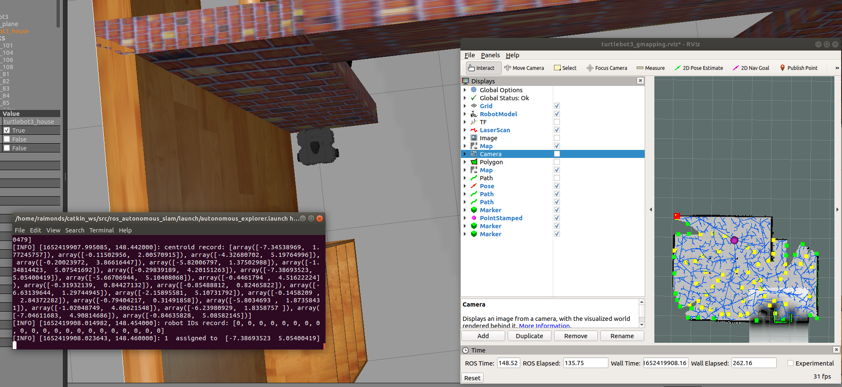

Figure 38: RRT, Turtlebot3 stuck – image before recovery teleop method used.

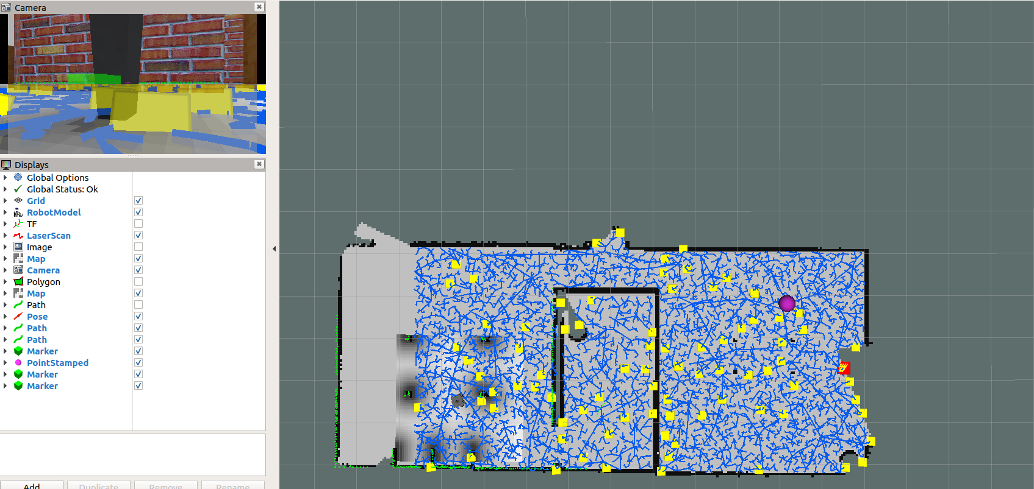

Figure 39: RRT exploration performance – with manually set up allocated area for exploration.

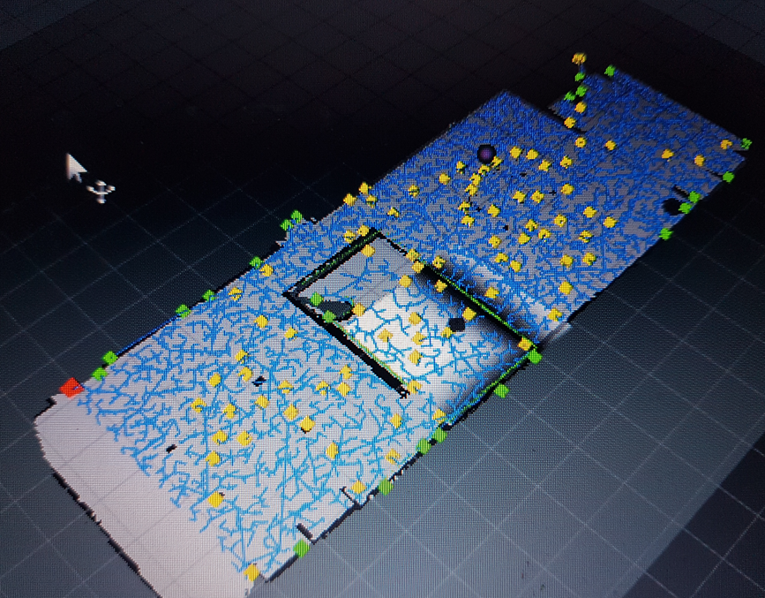

Figure 40: RRT exploration result with manually selected area.

## **Appendix C – Technical documentation**

### **C.1 – Introduction**

This section provides guidance to replicate set up to perform tests for open-source users. This documentation requires knowledge of ROS and Turtlebot3.

For required guidance please refer to:

* ROS tutorials guides - <http://wiki.ros.org/ROS/Tutorials>
* Turtlebot3 - <https://emanual.robotis.com/docs/en/platform/turtlebot3/quick-start/>
* Explore_lite - <http://wiki.ros.org/explore_lite>
* RRT - <http://wiki.ros.org/rrt_exploration>

### **C.2 – Setup**

Assuming all packages are installed and configured

**Gazebo** – For all the simulations it is required to put Turtlebot3 Waffle Pi model in simulation environment: Termina 1 and 2 applies for all packages

Terminal 1 –

* roscore

Terminal 2 –

* export TURTLEBOT3_MODEL=waffle
* roslaunch turtlebot3_gazebo turtlebot3_house.launch

**RRT**:

Terminal 3 –

* Roslaunch ros_autonomous_slam autonomous_explorer.launch

Package is autonomous from start, however in order to make algorithm work – follow exact sequence of PUBLISH points to define region as per Figure 41.

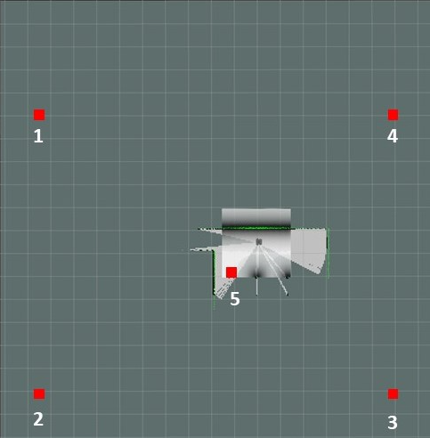

Figure 41: Publish point sequence required to start RRT.

**Explore_lite**:

Terminal 3 –

* roslaunch turtlebot3_slam turtlebot3_slam.launch slam_methods:=gmapping

Terminal 4 –

* roslaunch turtlebot3_navigation move_base.launch

Terminal 5 –

* roslaunch explore_lite explore.launch

Package is fully autonomous and do not require any other input from user

**Gmapping**

Terminal 3 –

* roslaunch turtlebot3_slam turtlebot3_slam.launch slam_methods:=gmapping

Terminal 4 –

* roslaunch turtlebot3_teleop turtlebot3_teleop_key.launch

This allows to draw 2D grid map of the environment with manual teleop control

At any stage map can be saved via command in separate terminal –

* rosrun map_server map_saver

In home directory 2 files will be created – map.pgm can be viewed by used any time / .yaml will be used by ROS further

When map is created, please close Terminal 3. Afterwards in open new terminal and use:

* roslaunch turtlebot3_navigation turtlebot3_navigation.launch map_file:=$HOME/map.yaml

ROS will use previously created map for navigation stack. In navigation stack you can order Turtlebot3 to proceed in desired location by setting *Nav goal* option in Rviz.

**Turtlebot3 + Laptop –** This setup assumes followed instruction for networking and other related aspects to Turtlebot3 + ROS master on remoted PC are setup up and Turtlebot3 is powered on

Terminal 1 –

* roscore

Terminal 2 –

* ssh pi@{IP_ADDRESS_OF_RASPBERRY_PI}

After enter default password –

* turtlebot

If date/time is not synchronized –

* sudo date -s "$(curl [http://s3.amazonaws.com](http://s3.amazonaws.com/) -v 2>&1 | \  
    grep "Date: " | awk '{ print $3 " " $5 " " $4 " " $7 " " $6 " GMT"}')"
* roslaunch turtlebot3_bringup turtlebot3_robot.launch

Last command launchers ROS Turtlebot3 related packages and allows further communication between robot and ROS master on remove PC

Afterwards all the instruction from Gazebo can be followed to run packages. Terminal 2 in this section literally replaces Terminal 2 part from Gazebo section. However, as previously was mentioned it requires much complicated setup.

# **List of Figures**

1: Revised Gantt Chart of the Final year project (From the reflective report)…10

2: Graph-Based Path Planning: Dijkstra’s Algorithm ………………………....15

3: Occupancy Grid map built using Lidar SLAM ………………………….….16

4: Imaginary Lidar scan of the robot towards obstacle…………………………17

5: Map of obstacles wrongly resembling real environment ……………………18

6: Pose Graph Optimization loop closure correction…………………………...18

7: Work order diagram of ROS ………………………………………………...20

8: Diagram of Gmapping ROS node structure………………………………….23

9: Gmapping algorithm flowchart.……………..……………………………….24

10: Frontier generated points with respect to robot position……………………26

11: General structure of the explore_lite……………………………………….27

12: A state where frontier target is calculated on an obstacle………………….28

13: RRT exploration algorithm process in multiple frames…………………....30

14: Propagation of RRT Algorithm for exploring unknown environment……..32

15: RRT package node diagram………………………………………………..32

16: 2D generated occupancy Grid map example.………………………………35

17: The life cycle of an agile testing approach…………………………………36

18: SLAM experiment in Gazebo with Turtlebot3.…………………………….41

19: Navigation stack experiment with corrected pose after movement….…….42

20: Turtlebot3 waffle_pi model transfer tree (TF) visualization in Rviz………42

21: Fully assembled – 3-layer TurtleBot waffle Pi ……………………………44

22: Turtlebot3 layer two – top view ……………………………………..…….44

23: Network connection IP address configrutation for Turtlebot3 and Laptop...45

24: Traceback script with Amazon AWS server connection.……….……….…46

25: Turtlebot3 teleoperations experiment ………………………………………47

26: roscore command provided information ………………………………..….48

27: Encountered param error……………………………………………………48

28: House map from Gazebo simulation tool ………………………………..…50

29: Explore_lite produced map with minimal unexplored spaces ……………...51

30: Gazebo House map error area for all SLAM packages …………………...52

31: RRT wrongly assigned error example ……………..……………………...52

32: Factual environment Grid map with legend.……………………………….54

33: Full list with details of Turtlebot3 hardware components………………….62

34: Gmapping navigation stack launch with failed pose………………….……63

35: Gmapping navigation without SLAM created map – Autonomous with 2D

nav goal. Map created with TB3 magnetic field……………………………….63

36: Gmapping Error within unknown environment, including recovery procedures……………………………………………………………………...64

37: Explore_lite fully autonomous SLAM success of complete map.………....64

38: RRT, Turtlebot3 stuck – image before recovery teleop method used……..64

39: RRT exploration performance – with manually set up allocated area for exploration……………………………………………………………………..65

40: RRT exploration result with manually selected area.……………..….……65

41: Publish point sequence required to start RRT.………………………….…67

# **List of tables**

1. Gazebo simulation results including Gmapping teleop……………………51

2. Factual environment test results, with additional measurement values……55

